**INTRODUCTION TO COMPUTING**

**(COM 111)**

**LECTURER – NDUESO WALTER OKORIE**

**PROGRAMME – NATIONAL DIPLOMA**

**DEPARTMENT - COMPUTER SCIENCE**

**1.0 COMPUTER**

A computer is an electronic device, operating under the control of instructions stored in its own memory that can accept data (input), process the data according to specified rules, produce information (output), and store the information for future use.

It can also be defined as a programmable device or an electronic machine that can accept data, processed the data, store information when necessary for future use and produce information as output using a set of instructions called program.

**FUNCTIONALITIES OF A COMPUTER**

Any digital computer carries out the five functions in gross term. They include:

1. Takes data as input
2. Store data/instructions in its memory and used them when required.
3. Processes the data and convert it to useful information.
4. Generate output
5. Control all the above four steps with set of instructions(program)

A computer is described as an electronic device because; it is made up of electronic components and uses electric energy (such as electricity) to operate.

A computer has an internal memory, which stores data & instructions temporarily awaiting processing, and even holds the intermediate result (information) before it is communicated to the recipients through the Output devices.

It works on the data using the instructions issued, means that, the computer cannot do any useful job on its own. It can only work as per the set of instructions issued.

A computer will accept data in one form and produce it in another form. The data is normally held within the computer as it is being processed.

**1.1 CHARACTERISTICS / FEATURES OF A COMPUTER.**

They following are some of the attributes that make computers widely accepted & used in the day-to-day activities in our society:

1. **Speed**.

Computers operate at very high speeds, and can perform very many functions within a very short time.  
They can perform a much complicated task much faster than a human being.

The speed of a computer is measured in Fractions of seconds.

Millisecond - a thousandth of a second (10-3)

Microsecond - a millionth of a second (10-6)

Nanosecond - a thousand millionth of a second (10-9)

Picosecond - a million millionth of a second (10-12)

The speed of a computer is usually linked to the technology used to build it.

2. **Accuracy**:

Unlike human beings, computers are very accurate, i.e., they never make mistakes.   
A computer can work for very long periods without going wrong. However, when an error occurs the computer has a number of in-built, self-checking features in their electronic components that can detect & correct such errors. Usually errors are committed by the users entering the data to the computer, thus the saying Garbage in Garbage Out (GIGO).

This means that, if you enter incorrect data into the computer and have it processed, the computer will give you misleading information.

3. **Reliability**.

The computer can be relied upon to produce the correct answer if it is given the correct instructions & supplied with the correct data.

Therefore, if you want to add two numbers, but by mistake, give the computer a “Multiply” instruction, the computer will not know that you intended to “ADD”; it will multiply the numbers supplied.  
  
Therefore, the output produced by a computer is only as reliable as the instructions used & the data supplied.  
4. **Consistency**:

Computers are usually consistent. This means that, given the same data & the same instructions, they will produce the same answer every time that particular process is repeated.

5. **Storage**:

computer is capable of storing large amounts of data or instructions in a very small space.

computer can store data & instructions for later use, and it can produce/ retrieve this data when required so that the user can make use of it.

6. **Diligence**:

Unlike human beings, a computer can work continuously without getting tired or bored. Even if it has to do a million calculations, it will do the last one with the same speed and accuracy as the first one.  
  
7. **Automation**

A computer is an automatic device. This is because, once given the instructions, it is guided by these instructions and can carry on its job automatically until it is complete.  
It can also perform a variety of jobs as long as there is a well-defined procedure.

**8. Versatile:**

Versatility refers to the capability of a computer to perform different kinds of works with same accuracy and efficiency.

**1.2 ADVANTAGES OF USING COMPUTER**

Now that we know the characteristics of computers, we can see the advantages that computers offer−

* Computers can do the same task repetitively with same accuracy.
* Computers do not get tired or bored.
* Computers can take up routine tasks while releasing human resource for more intelligent functions.

**1.3 DISADVANTAGES OF USING COMPUTER**

Despite so many advantages, computers have some disadvantages of their own −

* Computers have no intelligence; they follow the instructions blindly without considering the outcome.
* Regular electric supply is necessary to make computers work, which could prove difficult everywhere especially in developing nations.

# **1.4 HISTORICAL DEVELOPMENT OF COMPUTERS**

The abacus, which emerged about 5,000 years ago in Asia Minor and is still in use today, may be considered the first computer. This device allows users to make computations using a system of sliding beads arranged on a rack. Early merchants used the abacus to keep trading transactions. But as the use of paper and pencil spread, particularly in Europe, the abacus lost its importance. It took nearly 12 centuries, however, for the next significant advance in computing devices to emerge.

Calculating devices took a different turn when [John Napier](https://www.britannica.com/biography/John-Napier), a Scottish mathematician, published his discovery of [logarithms](https://www.britannica.com/science/logarithm) in 1614. As any person can attest, adding two 10-digit numbers is much simpler than multiplying them together, and the transformation of a multiplication problem into an addition problem is exactly what logarithms enable.

About 1632 an English clergyman and mathematician named [William Oughtred](https://www.britannica.com/biography/William-Oughtred) built the first [slide rule](https://www.britannica.com/science/slide-rule), drawing on Napier’s ideas. That first slide rule was circular, but Oughtred also built the first rectangular one in 1633. The analog devices of Gunter and Oughtred had various advantages and disadvantages compared with digital devices such as the abacus. What is important is that the consequences of these design decisions were being tested in the real world.

In 1642, Blaise Pascal (1623-1662), the 18-year-old son of a French tax collector, invented what he called a numerical wheel calculator to help his father with his tax duties. This brass rectangular box, also called a Pascaline, used eight movable dials to add sums up to eight figures long. Pascal's device used a base of ten to accomplish this. For example, as one dial moved ten notches, or one complete revolution, it moved the next dial - which represented the ten's column - one place. When the ten's dial moved one revolution, the dial representing the hundred's place moved one notch and so on. The drawback to the Pascaline, of course, was its limitation to addition.

 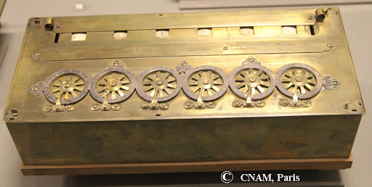

*Abacus pascaline*

In 1671 the German mathematician-philosopher [Gottfried Wilhelm von Leibniz](https://www.britannica.com/biography/Gottfried-Wilhelm-Leibniz) designed a calculating machine called the [Step Reckoner](https://www.britannica.com/technology/Step-Reckoner). (It was first built in 1673.) The Step Reckoner expanded on Pascal’s ideas and did multiplication by repeated addition and shifting.

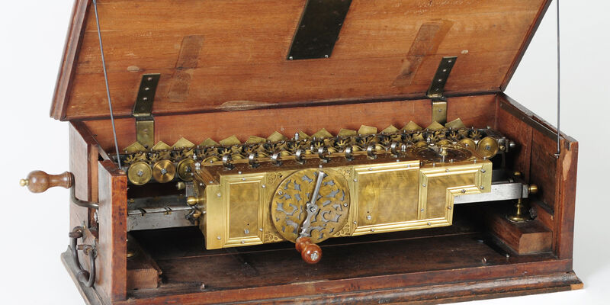

*Step reconkoner*

The Jacquard loom was invented in 1804 by Joseph Marie Jacquard. It was a textile-weaving loom which could also be called the first practical information-processing device. The loom worked by tugging various-coloured threads into patterns by means of an array of rods. By inserting a [card punched](https://www.britannica.com/technology/punched-card) with holes, an operator could [control](https://www.britannica.com/technology/control-system) the motion of the rods and thereby alter the pattern of the weave. Moreover, the loom was equipped with a card-reading device that slipped a new card from a prepunched deck into place every time the shuttle was thrown, so that complex weaving patterns could be automated.

Charles Babbage While working on the [Difference Engine](https://www.britannica.com/technology/Difference-Engine), a simpler calculating [machine](https://www.britannica.com/technology/machine) commissioned by the British government, Babbage began to imagine ways to improve it. Chiefly he thought about generalizing its operation so that it could perform other kinds of calculations. By the time funding ran out for his Difference Engine in 10 April, 1833, he had conceived of something far more revolutionary: a general-purpose computing machine called the [Analytical](https://www.merriam-webster.com/dictionary/Analytical) Engine. In 1834

The Analytical Engine was to be a general-purpose, fully program-controlled, automatic mechanical [digital computer](https://www.britannica.com/technology/digital-computer). It would be able to perform any calculation set before it. There is no evidence that anyone before Babbage had ever conceived of such a device, let alone attempted to build one. The machine was designed to consist of four components: the mill, the store, the reader, and the printer. These components are the essential components of every computer today. The mill was the calculating unit, [analogous](https://www.merriam-webster.com/dictionary/analogous) to the [central processing unit](https://www.britannica.com/technology/central-processing-unit) (CPU) in a modern computer; the store was where data were held prior to processing, exactly analogous to [memory](https://www.britannica.com/technology/computer-memory) and storage in today’s computers; and the reader and printer were the [input and output devices](https://www.britannica.com/technology/input-output-device).

The reader was another new feature of the Analytical Engine. Data (numbers) were to be entered on [punched cards](https://www.britannica.com/technology/punched-card), using the card-reading [technology](https://www.britannica.com/technology/technology) of the [Jacquard loom](https://www.britannica.com/technology/Jacquard-loom). Instructions were also to be entered on cards, another idea taken directly from [Joseph-Marie Jacquard](https://www.britannica.com/biography/Joseph-Marie-Jacquard). The use of instruction cards would make it a programmable device and far more flexible than any machine then in existence. (In 1843 mathematician [Ada Lovelace](https://www.britannica.com/biography/Ada-Lovelace) wrote in her notes for a translation of a French article about the Analytical Engine how the machine could be used to follow a program to calculate Bernoulli numbers. For this, she has been called the first computer programmer.) Another element of programmability was to be its ability to execute instructions in other than sequential order. It was to have a kind of decision-making ability in its conditional control transfer, also known as [conditional branching](https://www.britannica.com/technology/conditional-branching), whereby it would be able to jump to a different instruction depending on the value of some data. This extremely powerful feature was missing in many of the early computers of the 20th century.

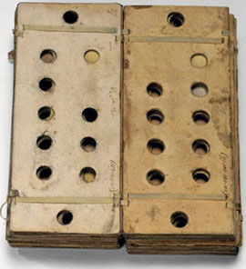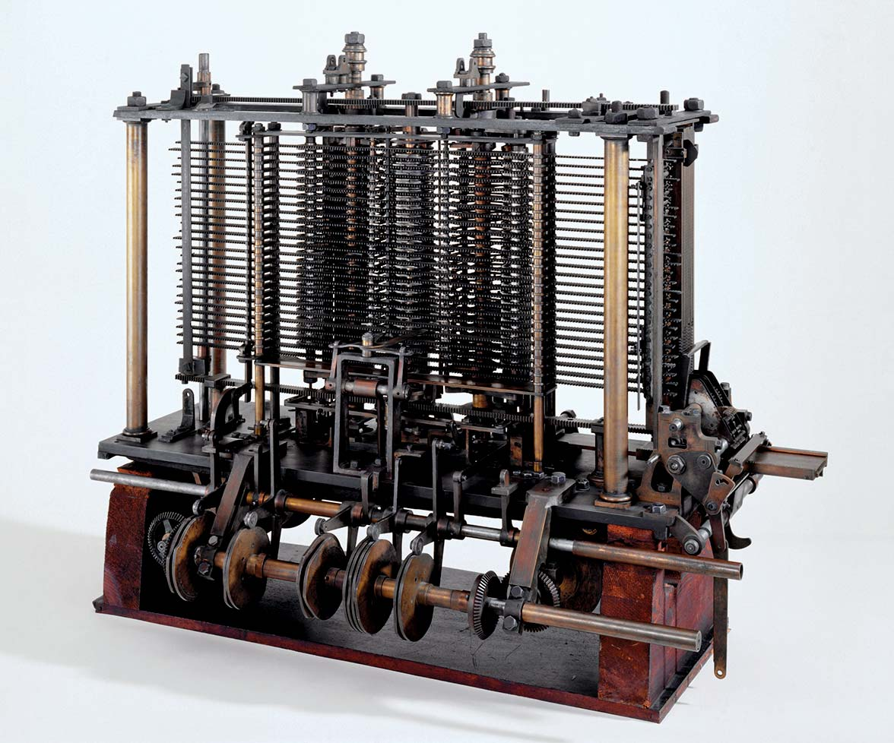

*Punched card Analytical machine*

In 1889, an American inventor, Herman Hollerith (1860-1929), also applied the Jacquard loom concept to computing. His first task was to find a faster way to compute the U.S. census. The previous census in 1880 had taken nearly seven years to count and with an expanding population, the bureau feared it would take 10 years to count the latest census. Unlike Babbage's idea of using perforated cards to instruct the machine, Hollerith's method used cards to store data information which he fed into a machine that compiled the results mechanically. Each punch on a card represented one number, and combinations of two punches represented one letter. As many as 80 variables could be stored on a single card. Instead of ten years, census takers compiled their results in just six weeks with Hollerith's machine. In addition to their speed, the punch cards served as a storage method for data and they helped reduce computational errors. Hollerith brought his punch card reader into the business world, founding Tabulating Machine Company in 1896, later to become International Business Machines (IBM) in 1924 after a series of mergers. Other companies such as Remington Rand and Burroghs also manufactured punch readers for business use. Both business and government used punch cards for data processing until the 1960's.

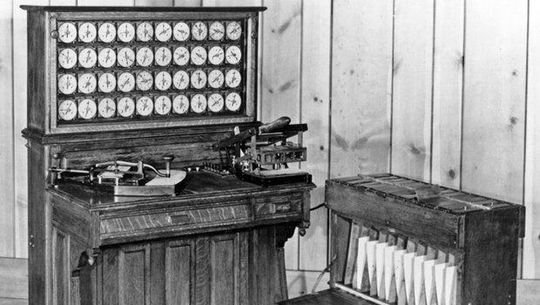

#### Hollerith Tabulating machine

In 1942, physicist John Mauchly proposed an all-electronic calculating machine made up of 18,000 vacuum tubes. The result was ENIAC (Electronic Numerical Integrator And Computer), built between 1943 and 1945 during world war 11. **ENIAC**, the first programmable general-purpose electronic digital [computer](https://www.britannica.com/technology/computer), built during [World War II](https://www.britannica.com/event/World-War-II) by the United States. American physicist [John Mauchly](https://www.britannica.com/biography/John-Mauchly), American engineer [J. Presper Eckert, Jr.](https://www.britannica.com/biography/J-Presper-Eckert-Jr), and their colleagues at the Moore School of Electrical Engineering at the [University of Pennsylvania](https://www.britannica.com/topic/University-of-Pennsylvania) led a government-funded project to build an all-electronic computer.

**ENIAC** was designed and primarily **used to** calculate artillery firing tables for the United States Army's Ballistic Research Laboratory . ENIAC was the first large-scale computer to run at electronic speed without being slowed by any mechanical parts.

**1.5 GENERATION OF COMPUTER**

Generation of computer means changes in technology used in building computers..

There are five computer generations known till date.

**First Generation**

The period of first generation was from 1946-1959. The computers of first generation used vacuum tubes as the basic components for memory and circuitry for CPU (Central Processing Unit). These tubes, like electric bulbs, produced a lot of heat and the installations used to fuse frequently.

In this generation, mainly batch processing operating system was used. Punch cards, paper tape, and magnetic tape was used as input and output devices. The computers in this generation used machine code as the programming language.

**Characteristics**

* Vacuum tube technology
* Unreliable
* Supported machine language only
* Very costly
* Generated a lot of heat
* Slow input and output devices
* Huge size
* Need of AC
* Non-portable
* Consumed a lot of electricity

Examples of first-generation computing devices were : ENIAC, EDVAC, UNIVAC, IBM-701, IBM-650 etc

**SECOND GENERATION**

The period of second generation was from 1959-1965. In this generation, transistors were used that were cheaper, consumed less power, more compact in size, more reliable and faster than the first generation machines made of vacuum tubes. In this generation, magnetic cores were used as the primary memory and magnetic tape and magnetic disks as secondary storage devices.

In this generation, assembly language and high-level programming languages like FORTRAN, COBOL were used.

**Characteristic**

* Use of transistors
* Reliable in comparison to first generation computers
* Smaller size as compared to first generation computers
* Generated less heat as compared to first generation computers
* Consumed less electricity as compared to first generation computers
* Faster than first generation computers
* Still very costly
* AC required
* Supported machine and assembly languages

Examples Of Second Generation Computer

IBM 1620, IBM 7094, CDC 1604, CDC 3600, UNIVAC 1108 ETC

**Third generation**

The period of third generation was from 1965-1971 .The development of the [integrated circuit](https://www.webopedia.com/TERM/I/integrated_circuit_IC.html) was the hallmark of the third generation of computers. Instead of punched cards and printouts, users interacted with third generation computers through [keyboards](https://www.webopedia.com/TERM/K/keyboard.html) and [monitors](https://www.webopedia.com/TERM/M/monitor.html) and [interfaced](https://www.webopedia.com/TERM/I/interface.html) with an [operating system](https://www.webopedia.com/TERM/O/operating_system.html), which allowed the device to run many different [applications](https://www.webopedia.com/TERM/A/application.html) at one time with a central program that monitored the memory.

**Characteristics**

* Integrated Circuit used
* More reliable in comparison to previous two generations
* Keyboard and monitor were introduced.
* Operating system was introduced for better resource management
* Smaller size
* Generated less heat
* Faster
* Lesser maintenance
* Costly
* AC required
* Consumed lesser electricity
* Supported high-level language

**Examples**: IBM-360 series, Honeywell-6000 series, PDP (Personal Data Processor), IBM-70/168, TDC-316 etc

**Fourth Generation**

The period of fourth generation was from 1971-1980. Integrated circuit was replaced with microprocessor. The [microprocessor](https://www.webopedia.com/TERM/M/microprocessor.html) brought the fourth generation of computers, as thousands of integrated circuits were built onto a single silicon chip. The Intel 4004 chip, developed in 1971, located all the components of the computer—from the [central processing unit](https://www.webopedia.com/TERM/C/CPU.html) and memory to input/output controls—on a single chip.

In 1981 [IBM](https://www.webopedia.com/TERM/I/IBM.html) introduced its first computer for the home user, and in 1984 [Apple](https://www.webopedia.com/TERM/A/Apple_Computer.html) introduced the Macintosh.

**Characteristics**

• The technology is based on Microprocessor.

• Graphics User Interface (GUI) technology was exploited to offer more comfort to users.

• Very cheap and affordable

• Portable and reliable

• Microcomputers were introduced.

• Very small size

• Pipeline processing

• No AC required

**Few Examples are:**

IBM 4341,DEC 10,STAR 1000,PDP 11, CRAY-1(Super Computer), CRAY-X-MP(Super computer)

## ****Fifth Generation:****

Fifth generation computing devices, based on [artificial intelligence](https://www.webopedia.com/TERM/A/artificial_intelligence.html). The period of fifth generation started in 1980 and are still in development. The aim of the fifth generation is to make a device which could respond to natural language input and are capable of learning and self-organization.

Characteristics

* This generation is based on artificial intelligence.
* They respond natural language.
* They are expert system.
* This generation is based on ULSI (Ultra Large Scale Integration) technology resulting in the production of microprocessor chips having ten million electronic component.

**Examples**:

Desktop, Laptop, Notebook, UltraBook, ChromeBook etc

**1.6 CLASSIFICATION OF COMPUTERS**

The computer systems can be classified on the following basis:

1. According to Type (On the basis of data handling).

2. According to Purpose

3. According to Size

**According to Type**

The computer is of three types:

* [Analogue Computer](https://www.javatpoint.com/types-of-computer#Analogue)
* [Digital Computer](https://www.javatpoint.com/types-of-computer#Digital)
* [Hybrid Computer](https://www.javatpoint.com/types-of-computer#Hybrid)

## 1) Analogue Computer

Analogue computers are computers designed to **process analogue data**. Analogue data is continuous data that changes continuously and cannot have discrete values. We can say that analogue computers are used where we don't need exact values always such as speed, temperature, pressure and current.

Analogue computers directly accept the data from the measuring device without first converting it into numbers and codes. They measure the continuous changes in physical quantity and generally render output as a reading on a dial or scale. **Speedometer** and **mercury thermometer** are examples of analogue computers.

## 2) Digital Computer

This is A [computer](https://ecomputernotes.com/fundamental/introduction-to-computer/what-is-computer) that performs calculations and logical operations with quantities represented as digits, usually in the [binary number system](https://ecomputernotes.com/fundamental/number-system/binary-numbers). All modern computers like laptops, desktops including smartphones that we use at home or office are digital computers.

## 3) Hybrid Computer

Hybrid computer has features of both analogue and digital computer. It is **fast like an analogue** computer and has memory and **accuracy like digital computers**. It can process both continuous and discrete data. It accepts analogue signals and convert them into digital form before processing. So, it is widely used in specialized applications where both analogue and digital data is processed. For example, a processor is used in petrol pumps that converts the measurements of fuel flow into quantity and price. Similarly, they are used in airplanes, hospitals, and scientific applications.

**According to Size**

**On the basis of size**, the computer can be of five types:

## 1) Supercomputer

Supercomputers are the **biggest and fastest computers**. They are designed to process huge amount of data. A supercomputer can **process trillions of instructions in a second**. It has thousands of interconnected processors.

Supercomputers are particularly used in **scientific and engineering applications** such as weather forecasting, scientific simulations and nuclear energy. Other uses of supercomputers include animated graphics, fluid dynamic calculations, nuclear energy research, and petroleum exploration. The first supercomputer was developed by **Roger Cray in 1976**. Examples of supercomputer is cray1, Belle, Deep Blue, and Hydra, for playing chess, Gravity Pipe for astrophysics, MDGRAPE-3 for protein **structure** computation molecular dynamics and Deep Crack, for breaking the DES cipher.

**2) Mainframe computer**

Mainframe computers are designed to support hundreds or thousands of users simultaneously. They can support multiple programs at the same time. It means they can execute different processes simultaneously. These features of mainframe computers make them ideal for big organizations like banking and telecom sectors, which need to manage and process high volume of data.

## 3) Minicomputer

It is a midsize multiprocessing computer. It consists of two or more processors and can support 4 to 200 users at one time. A minicomputer lies between the mainframe and microcomputer as it is smaller than mainframe but larger than a microcomputer.

## 4) Workstation

Workstation is a single user computer that is designed for technical or scientific applications. It has a faster microprocessor, a large amount of RAM and high speed graphic adapters. It generally performs a specific job with great expertise; accordingly, they are of different types such as graphics workstation, music workstation and engineering design workstation.

## 5) Microcomputer

Microcomputer is also known as a personal computer. It is a general-purpose computer that is designed for individual use. It has a microprocessor as a central processing unit, memory, storage area, input unit and output unit. Laptops and desktop computers are examples of microcomputers. They are suitable for personal work that may be making an assignment, watching a movie, or at office for office work.

**According to purpose**

According to purpose, computers are either general purpose or specific purpose.

**General purpose computers** are designed to perform a range of tasks. They have the ability to store numerous programs, but lack in speed and efficiency.

**Specific purpose computers** are designed to handle a specific problem or to perform a specific task. A set of instructions is built into the machine.

**1.7 BENEFITS OF COMPUTER TO THE SOCIETY**

## Work

Computers are now used in every domain, field and sector and across industries. They are used for a variety of tasks, applications and activities and to enhance productivity on all fronts.

## Communication

The advent of the Internet and its proliferation have force-multiplied the usage of computers. People all over the world are able to communicate, engage and interact with each other using IM, email, blogs, online forums, social media and other options.

## Jobs Influence

The widespread use and application of computers has created multiple industries, derived sectors and professions and facilitated job opportunities for millions of people.

## Entertainment

High-end desktops and full-featured notebook PCs have become all-in-one entertainment systems for millions of users as they watch movies, sports events and news programs, shop, socialize, download videos and play games.

## Education

## Through the use of advanced computing and telecommunications technology, learning can also be qualitatively different. The process of learning in the classroom can become significantly richer as students have access to new and different types of information, can manipulate it on the computer through graphic displays or controlled experiments in ways never before possible, and can communicate their results and conclusions in a variety of media to their teacher, students in the next classroom, or students around the world.

## Computers help students in any way they need, researching, typing, searching, etc. Teachers use computers as well. They use computers to keep track of grades, type out instruction for their students, and to let students use the computer for school purposes.

## Productivity

Computers increase your productivity and, with a good understanding of the [software](https://www.computerhope.com/jargon/s/software.htm) running on them, you become more productive at everything you do. For example, once you have a basic understanding of using a [word processor](https://www.computerhope.com/jargon/w/word-processor.htm), you can create, store, edit, share, and print documents and letters. Each of these things was either impossible or slower with all pre-existing technologies.

**Business**

Business organizations now have a number of tasks numbers to be processed. So many businesses have started using the computer, for example to calculate the salary, to identify the goods sold and are still in stock, to issue and send or receive business statements, letters, invoices and more.

The use of computers and office equipment to assist other managers, clerks, and the management of office automation mentioned. One of them is a word processing application which enables business owners or staff to produce and edit letters, reports, documents, and other than work in a few seconds to type manually.

We can also use computer to buy and sell products and services online without necessarily seeing the other person.

**Health**

An important field computers impacted on is the medical field. The computers helped the hospitals out very much. In pharmacies, the pharmacists use computers to keep a record of what medication to give to a patient and the amount they need. Most computers in the hospital are used to keep data of patience and their status. Computers also keep track of equipment placement and status as well. Scientists need the help of computers to find cures for diseases that need cures like cancer and STDs. Without the computers help, cures for a lot of diseases wouldn’t have been found.

**2.0 COMPUTER SYSTEM**

**Definition**:

A computer system is a basic, complete and functional hardware and software setup with everything needed to implement computing performance. It can also be defined as A system of interconnected computers that share a system and various devices. Each system has the ability to communicate and connect to other devices and systems.

**2.1 COMPONENTS OF COMPUTER SYSTEM**

A computer comprises of some [basic elements](https://www.toppr.com/guides/accountancy/application-of-computers-in-accounting/meaning-and-elements-of-computer-system/). These include hardware, software and Human ware. No computer can function in the absence of these elements. Apart from these elements, a computer system comprises of three basic components.

Every computer system has the following three basic components:

1. Input unit
2. Central processing unit
3. Output unit

These components must work in complete synergy because that will ensure smooth overall functioning. Hence, we can even call them building blocks of a computer system.

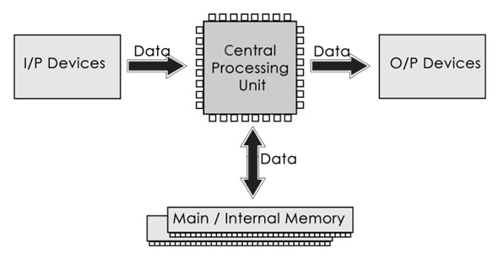

## Input Unit

These components help users enter data and commands into a computer system. Data can be in the form of [numbers](https://www.toppr.com/guides/computer-aptitude-and-knowledge/basics-of-computers/number-systems/), [words](https://www.toppr.com/guides/english/vocabulary/words/), actions, commands, etc. The main function of [input devices](https://www.toppr.com/guides/computer-aptitude-and-knowledge/basics-of-computers/input-and-output-devices/) is to direct commands and data into computers. Computers then use their CPU to process this data and produce output.

For example, a laptop’s [keyboard](https://www.toppr.com/guides/computer-aptitude-and-knowledge/basics/keyboard-shortcuts/) is an input unit that enters numbers and characters. Similarly, even a mouse can be an input unit for entering directions and commands. Other examples include barcode readers, Magnetic Ink Character Readers (MICR), Optical Character Readers (OCR), etc.

Other examples of input devices are scanner, mouse, light pen, and joystick

## Central Processing Unit

After receiving data and commands from users or input devices, a computer system now has to process it according to the instructions provided. Here, it has to rely on a component called the central processing [unit](https://www.toppr.com/guides/physics/units-and-measurements/). The Central Processing Unit (CPU) is called "the brain of computer" as it controls operation of all parts of computer. It consists of two components: Arithmetic Logic Unit (ALU), and Control Unit. The CPU further uses these three elements:

## Memory Unit

This is unit in which data and instructions given to computer as well as results given by computer are stored.

Once a user enters data using input devices, the computer system stores this data in its memory unit. This data will now remain here until other components of CPU process it. The [memory](https://www.toppr.com/guides/computer-aptitude-and-knowledge/basics-of-computers/computer-memory/) unit uses a [set](https://www.toppr.com/guides/business-mathematics-and-statistics/sets-relations-and-functions/basic-definitions-and-concepts/) of pre-programmed instructions to further transmit this data to other parts of the CPU.

## Output Unit

The third and final component of a computer system is the output unit. An output device is a piece of computer hardware that receives data from a computer and then translates that data into another form. That form may be audio, visual, textual, or hard copy such as a printed document. After processing of data, it is converted into a format which humans can understand. After conversion, the output units displays this data to users. Examples of output devices include monitors, screens, printers and speakers. Thus, output units basically reproduce the data formatted by the computer for users’ benefit.

**2.2 COMPUTER HARDWARE AND SOFTWARE**

## Hardware

The term hardware refers to the physical components of the computer. Hardware refers to mechanical device that makes up computer. Computer hardware consists of interconnected electronic devices that we can use to control computer’s operation, input and output. Examples of hardware are system unit, CPU, keyboard, mouse, hard disk, etc

**2.2.1 COMPONENTS OF THE COMPUTER HARDWARE**

The 3 major components of the computer hardware include:

1. Input Unit
2. Central Processing unit
3. Output unit

**Input unit**

An **input unit or device** is a piece of hardware used to provide data to a computer used for interaction and control.  It allows input of raw data to the computer for processing.

Here’s a list of some input devices used in computers and other computing devices:

* **Keyboard** – one of the primary input devices used to input data and commands. It has function keys, control keys, arrow keys, keypad and the keyboard itself with the letters, numbers and commands
* **Mouse** – an input device used to control the cursor and coordinates. It can be wired or wireless.  It allows the user to do the following:
  + Move the mouse cursor
  + Select
  + Scroll
  + Open or execute a program
  + Drag-and-drop
  + Hover
  + Perform other functions with the use of additional buttons
  + A laptop uses a touchpad as the mouse.  A smartphone and tablet use a touchscreen as primary input device and the user’s finger is used as the mouse.
* **Microphone** – an input device that allows users to input audio into their computers. Here are some uses of the microphone:
  + Audio for video
  + Computer gaming
  + Online chatting
  + Recording musical instruments
  + Recording voice for dictation, singing and podcasts
  + Voice recorder
  + Voice recognition
  + VoIP – Voice over Internet Protocol
* **Digital Camera** – is an input device that takes pictures digitally. Images are stored as data on memory cards.  It has an LCD screen that allows users to preview and review images.  Digital cameras have become popular over film cameras because of the following features:
  + LCD screen – allows users to view the photos and videos immediately
  + Storage – can store thousands of pictures
  + Picture development – allows users to choose and pick which pictures to develop
  + Size – takes up less space and can be easily carried
* **Scanner** – is an input device that reads an image and converts it into a digital file. A scanner is connected to a computer through USB.
* **Touchscreen** – is an input device that allows users to interact with a computer using their fingers. It is used widely in laptop monitors, smartphones, tablets, cash registers and information kiosks.  Most common functions of touchscreens are as follows:
  + Tap
  + Double-tap
  + Touch and hold
  + Drag
  + Swipe
  + Pinch
* **Barcode Reader** – also known as barcode scanner or point of sale (POS) scanner, is an input device capable of reading barcodes.
* **Webcam** – is an input device connected to the computer and the internet that captures still picture or motion video.
* **Biometric devices** – is an input device used to input biometric data into a computer. Here are the types of biometric devices:
  + Face scanner
  + Hand scanner
  + Finger scanner
  + Voice scanner
* **Stylus** – is a pen-shaped input device used to write or draw on the screen of a graphic tablet or device. Initially it was just used for graphic tablets and PDAs, but now, it has become popular on mobile devices as a replacement for the user’s fingers.  It’s used for more accurate navigation and to keep oils from user’s fingers off the device screen.

**Output Unit**

An output device is any [peripheral](https://www.computerhope.com/jargon/p/peripher.htm) that receives data from a computer, usually for display, projection, or physical reproduction. For example, the image shows an inkjet printer, an output device that make a [hard copy](https://www.computerhope.com/jargon/h/hardcopy.htm) of anything shown on the monitor. The **output unit** is used to present soft and hardcopy of information. Monitors and printers are two of the most commonly used output devices used with a computer. Other examples include: speaker, plotter, 3D printer etc

**2.2.2 PERIPHERAL DEVICES**

## **Peripheral device**, also known as **peripheral**, **computer peripheral**, **input-output device**, or **input/output device**, any of various devices (including sensors) used to enter information and instructions into a [computer](https://www.britannica.com/technology/computer) for storage or processing and to deliver the processed data to a human operator. It can also be defined as any computer device or parts connected to the system unit mostly through cables or USB.

## Types of Peripheral Devices

There are many different peripheral devices, but they fall into three general categories:

1. **Input devices**, such as a mouse and a keyboard
2. **Output devices**, such as a monitor and a printer
3. **Storage devices**, such as a hard drive or flash drive

**2.3 CENTRAL PROCESSING UNIT**

**Central processing unit (CPU)** is a principal part of any digital [computer](https://www.britannica.com/technology/computer) system, generally composed of the main [memory](https://www.britannica.com/technology/computer-memory), control unit, and arithmetic-logic unit. It [constitutes](https://www.merriam-webster.com/dictionary/constitutes) the physical heart of the entire computer system; to it is linked various [peripheral](https://www.britannica.com/technology/input-output-device) equipment, including [input/output devices](https://www.britannica.com/technology/input-output-device) and [auxiliary](https://www.merriam-webster.com/dictionary/auxiliary) storage units. In modern computers, the CPU is contained on an [integrated circuit](https://www.britannica.com/technology/integrated-circuit) [chip](https://www.britannica.com/technology/computer-chip) called a [microprocessor](https://www.britannica.com/technology/microprocessor). It is also regarded as the heart of the computer because it controls and co-ordinate activities in the computer. CPU performs all types of data processing operations. It stores data, intermediate results, and instructions (program). It controls the operation of all parts of the computer.

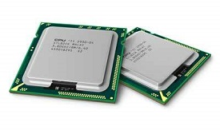

CPU itself has following three components.

* Memory or Storage Unit
* Control Unit
* ALU(Arithmetic Logic Unit)

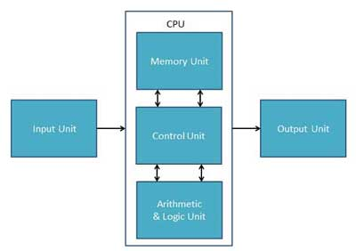

*Diagram showing components of cpu*

## Memory or Storage Unit

This unit stores instructions, data, and intermediate results. This unit supplies information to other units of the computer when needed. It is also known as internal storage unit or the main memory or the primary storage or Random Access Memory (RAM).

Its size affects speed, power, and capability. Primary memory and secondary memory are two types of memories in the computer. Functions of the memory unit are −

* It stores all the data and the instructions required for processing.
* It stores intermediate results of processing.
* It stores the final results of processing before these results are released to an output device.
* All inputs and outputs are transmitted through the main memory.

## Control Unit

This unit controls the operations of all parts of the computer but does not carry out any actual data processing operations.

Functions of this unit are −

* It is responsible for controlling the transfer of data and instructions among other units of a computer.
* It manages and coordinates all the units of the computer.
* It obtains the instructions from the memory, interprets them, and directs the operation of the computer.
* It communicates with Input/Output devices for transfer of data or results from storage.
* It does not process or store data.

## ALU (Arithmetic Logic Unit)

This unit consists of two subsections namely,

* Arithmetic Section
* Logic Section

### Arithmetic Section

Function of arithmetic section is to perform arithmetic operations like addition, subtraction, multiplication, and division. All complex operations are done by making repetitive use of the above operations.

### Logic Section

Function of logic section is to perform logic operations such as comparing, selecting, matching, and merging of data

## The Four Primary Functions of the CPU

**2.4 AUXILIARY UNIT**

**Auxiliary** [**memory**](https://ecomputernotes.com/fundamental/input-output-and-memory/memory) (also referred to as secondary storage) is where programs and data kept for long-term storage or when not in immediate use .

Auxiliary memory may also refer to as auxiliary storage, secondary storage, secondary memory, external storage or external memory. **Auxiliary memory** is not directly accessible by the [CPU](https://ecomputernotes.com/fundamental/introduction-to-computer/what-is-cpu); instead, it stores noncritical system data like large data files, documents, programs and other back up [information](https://ecomputernotes.com/fundamental/information-technology/what-do-you-mean-by-data-and-information) that supplied to primary memory from auxiliary memory over a high-bandwidth channel, which will use whenever necessary. Auxiliary memory holds data for future use, and that retains [information](https://ecomputernotes.com/fundamental/information-technology/what-do-you-mean-by-data-and-information) even the power fails.

Secondary memory devices are not only convenient for storing backup files, but they also allow [computer](https://ecomputernotes.com/fundamental/introduction-to-computer/what-is-computer) users to expand their ability to transfer large amounts of data to another Secondary memory devices.

Secondary memory devices are nonvolatile in nature and data does not disappear when the computer turned off and on again. Secondary memory is cheaper than primary memory but is also slower in both reading and writing.

**Examples of Auxiliary devices include:**

* Floppy Disks
* Hard Drives
* CD-ROM
* Tape Backup Drives
* ZIP Drives
* USB stick
* DVD ROM
* Magnetic tape

# **The Functions of auxiliary/Secondary Storage**

1. The function of secondary storage is the long-term retention of data in a computer system.
2. Secondary storage is non-volatile and not cleared when the computer is powered off and back on.
3. Secondary storage is cheaper than primary storage but is also slower in both read and write access.

**2.5 Units of Storage in computer**

1. **Bit (Binary Digit)**

A binary digit is logical 0 and 1 representing a passive or an active state of a component in an electric circuit. It is the smallest unit of measurement in computer.

1. **Nibble**

A group of 4 bits is called nibble.

1. **Byte**

A group of 8 bits is called byte. A byte is the basic unit of storage in computer.

1. **Word**

A computer word, like a byte, is a group of fixed number of bits processed as a unit, which varies from computer to computer but is fixed for each computer.

The length of a computer word is called word-size or word length. It may be as small as 8 bits or may be as long as 96 bits. A computer stores the information in the form of computer words.

1. **Kilobyte (KB)**

1 KB = 1024 Bytes

1. **Megabyte (MB)**

1 MB = 1024 KB

1. **GigaByte (GB)**

1 GB = 1024 MB

1. **TeraByte (TB)**

1 TB = 1024 GB

1. **PetaByte (PB)**

1 PB = 1024 TB

## 3.0 COMPUTER SOFTWARE

Software is a general name given to a set of instructions that drives computer to do stipulated tasks. It is also called a program. Software is a collection of programs to bring computer hardware system into operation. .

**3.1 TYPES OF SOFTWARE**

1) System software (2) Application Software

## System Software

System software operates directly on hardware devices of computer. It provides a platform to run an application. It provides and supports user functionality. Examples of system software include operating systems such as Windows, Linux, Unix, etc.

### **Application Software**

An application software is designed for benefit of users to perform one or more tasks. Examples of application software include Microsoft Word, Excel, PowerPoint, Oracle, etc.

**3.2 TYPES OF COMPUTER LANGUAGE**

They include:

* 1. Low-level language
  2. Middle level language
  3. High-level language

**Low-level language**

This language is the most understandable language used by computer to perform its operations. A low-level language is a type of [programming language](https://techterms.com/definition/programming_language) that contains basic instructions recognized by a computer. Unlike [high-level languages](https://techterms.com/definition/high-level_language) used by software [developers](https://techterms.com/definition/developer), low-level code is often cryptic and not human-readable. Two common e of low-level programming languages are [assembly language](https://techterms.com/definition/assembly_language) and [machine language](https://techterms.com/definition/machine_language).

**Middle level**

The middle-level language lies in between the low level and high-level language. C language is the middle-level language. By using the [C language](https://www.tutorialandexample.com/c-tutorial/), the user is capable of doing the system programming for writing operating system as well as application programming. These languages don’t provide all the built-in functions found in high level languages, but provide all building blocks that we need to produce the result we want. The [Java, C, C++](https://www.tutorialandexample.com/c-plus-plus-vs-java/) are also examples of middle-level languages.

**High level language**

Instructions of this language closely resembles to human language or English like words. It uses mathematical notations to perform the task. The high level language is easier to learn. It requires less time to write and is easier to maintain the errors. The high level language is converted into machine language by one of the two different languages translator programs; **interpreter or compiler.**

**Examples are** Java, C#, C++ , Basic, Fortran, Ruby, Perl, php, Vb.net, Smalltalk, Golang and Python

**3.3 TRANSLATOR**

Translator is a special software that convert sourcecode to machine code (0 and 1 ).

## Types of Translators

There are 3 different types of translators as follows:

### **Compiler**

A compiler is a translator used to convert high-level programming language to low-level programming language.  It converts the whole program in one session and reports errors detected after the conversion.  Compiler takes time to do its work as it translates high-level code to lower-level code all at once and then saves it to memory. Examples of programming languages that uses compiler are : C, C++, Java, C#, Scala, Microsoft Visual Studio, GNU Compiler Collection (GCC), Common Business Oriented Language (COBOL)

### **Interpreter**

Just like a compiler, is a translator used to convert high-level programming language to low-level programming language.  It converts the program one at a time and reports errors detected at once, while doing the conversion.  With this, it is easier to detect errors than in a compiler.  An interpreter is faster than a compiler as it immediately executes the code upon reading the code.  
It is often used as a debugging tool for software development as it can execute a single line of code at a time.  An interpreter is also more portable than a compiler as it is not processor-dependent, you can work between hardware architectures. Examples of programming languages that uses compiler are : OCaml, List Processing (LISP), Python, VB.NET, BASIC, Ruby, php, perl

### **Assembler**

An assembler is is a translator used to translate assembly language to machine language.  It is like a compiler for the assembly language but interactive like an interpreter.  Assembly language is difficult to understand as it is a low-level programming language.  An assembler translates a low-level language, an assembly language to an even lower-level language, which is the machine code.  The machine code can be directly understood by the CPU. Examples of programming languages that uses compiler are : Fortran Assembly Program (FAP) ,Macro Assembly Program (MAP), Symbolic Optimal Assembly Program (SOAP).

**3.4 DIFFERENCES BETWEEN COMPILER AND INTERPRETER**

|  |  |  |
| --- | --- | --- |
| S/No | **Compiler** | **Interpreter** |
| **1** | Performs the translation of a program as a whole. | Performs statement by statement translation. |
| **2** | Execution is faster. | Execution is slower. |
| **3** | Requires more [memory](https://ecomputernotes.com/fundamental/input-output-and-memory/memory) as linking is needed for the generated intermediate object code. | [Memory](https://ecomputernotes.com/fundamental/input-output-and-memory/memory) usage is efficient as no intermediate object code is generated. |
| **4** | Debugging is hard as the error messages are generated after scanning the entire program only. | It stops translation when the first error is met. Hence, debugging is easy. |
| **5** | Programming languages like C, C++ uses compilers. | Programming languages like [Python](https://ecomputernotes.com/python/what-is-python), BASIC, and Ruby uses interpreters. |

**3.5 BESPOKE APPLICATION AND APPLICATION SOFTWARE**

## What is Bespoke Software?

 Bespoke software is a software application developed specifically to your custom requirements and is particularly used when there is no 'off the shelf' alternative available.

**Examples**

* Order processing system
* Content management system (CMS)
* Ecommerce platform like Ebay, Amazon, Jumia etc
* Business process automation system
* Result checking system
* Customer relationship management system
* Banking systems including front/middle and back office applications
* Rail ticket booking system
* Airline ticket booking system

**Application software**

This is a type of program designed by programmers to solve a particular problem or performs specific task.

**Examples**

* Microsoft office like Ms Word, MS Excel , Ms Access etc
* Internet browsers like Firefox, Safari, and Chrome
* Mobile pieces of software such as Pandora (for music appreciation), Skype (for real-time online communication), and Slack (for team collaboration)

**4.0 DATA PROCESSING**

**Data processing** is the conversion of data into usable and desired form. This conversion or “processing” is carried out using a predefined sequence of operations either manually or automatically. Most of the processing is done by using computers and thus done automatically.

## 4.1 TYPES OF DATA PROCESSING ON BASIS OF PROCESS/STEPS PERFORMED

There are number of methods and techniques which can be adopted for processing of data depending upon the requirements, time availability, and software and hardware capability of the technology being used for data processing. There are number of types of data processing methods.

1. Batch Processing
2. Real time processing
3. Online Processing
4. Distributed Processing
5. Multiprocessing
6. Time sharing

### **Batch Processing**

Data is collected and processed in batches. Data is accumulated as a group (batch) over a specified period of time e.g. daily, weekly or monthly. The batch is then processed at once. For example in payroll processing system, employees details concerning the number of hours worked, rate of pay, and other details are collected for a period of time say, one month. These details are then used to process the payment for the duration worked. Most printing systems use the batch processing to print documents. Eg: payroll system

### **Online Processing**

This is a method that utilizes Internet connections and equipment directly attached to a computer. This allows the data to be stored in one place and being used at an altogether different place. Cloud computing can be considered as an example which uses this type of processing. It is used mainly for information recording and research.

### **Real-Time Processing**

As the name suggests this method is used for carrying out real-time processing. This is required where the results are displayed immediately or in lowest time possible. The data fed to the software is used almost instantaneously for processing purpose. The nature of processing of this type of data processing requires use of internet connection and data is stored/used online. Data is processed within seconds when the input is given. Used for small amounts of data. Example includes withdrawing money from ATM in banking system, tickets booking for flights, trains, movie tickets, rental agencies etc.

### **Distributed Processing**

This method is commonly utilized by remote workstations connected to one big central workstation or server. ATMs are good examples of this data processing method. All the end machines run on a fixed software located at a particular place and make use of exactly same information and sets of instruction.

### **Multi-Processing**

This type of processing perhaps the most widely used types of data processing. It is used almost everywhere and forms the basic of all computing devices relying on processors. Multi processing makes use of CPUs (more than one CPU). The task or sets of operations are divided between CPUs available simultaneously thus increasing efficiency and throughput. The break down of jobs which needs be performed are sent to different CPUs working parallel within the mainframe. The result and benefit of this type of processing is the reduction in time required and increasing the output . Moreover CPUs work independently as they are not dependent on other CPU, failure of one CPU does not result in halting the complete process as the other CPUs continue to work. Examples include processing of data and instructions in computer, laptops, mobile phones etc.

### **Time sharing**

Time based used of CPU is the core of this data processing type. The single CPU is used by multiple users. All users share same CPU but the time allocated to all users might differ. The processing takes place at different intervals for different users as per allocated time. Since multiple users can uses this type it is also referred as multi access system. This is done by providing a terminal for their link to main CPU and the time available is calculated by dividing the CPU time between all the available users as scheduled.

**5.0 PROCEDURES FOR COMPUTING OPERATIONS AND DATA PREPARATION METHOD**

**5.1 Booting**

Booting is a process of starting or preparing a computer for use. In computing, booting is the initial set of operations that a computer system performs when electrical power to the CPU is switched on.

During the boot process, the computer goes through multiple steps, to ensure the computer hardware works correctly, and the necessary software can be loaded. When booting, the computer performs the following tasks.

1. Pressing the power button on the computer starts up the power supply, which subsequently provides power to the other hardware [components](https://www.computerhope.com/jargon/c/component.htm) inside the [computer case](https://www.computerhope.com/jargon/c/chassis.htm).
2. A self-diagnostic is performed, also known as a [POST](https://www.computerhope.com/jargon/p/post.htm), to check if all hardware in the computer is working properly.
3. The [BIOS](https://www.computerhope.com/jargon/b/bios.htm) checks the [hard drive](https://www.computerhope.com/jargon/h/harddriv.htm) for the [boot loader](https://www.computerhope.com/jargon/b/bootload.htm), located in the first [sector](https://www.computerhope.com/jargon/s/sector.htm) of the hard drive.
4. The boot loader looks for the [operating system](https://www.computerhope.com/jargon/o/os.htm) on the hard drive and begins loading the found operating system (e.g., [Linux](https://www.computerhope.com/jargon/l/linux.htm), [macOS](https://www.computerhope.com/jargon/m/macos.htm), or [Windows](https://www.computerhope.com/jargon/w/windows.htm)).
5. Hardware [drivers](https://www.computerhope.com/jargon/d/driver.htm) are loaded, allowing the operating system to interact and utilize the [hardware](https://www.computerhope.com/jargon/h/hardware.htm) components inside the computer case.
6. If configured in the operating system, a login screen is displayed, allowing a user to enter a username and password to log in.
7. Any additional software programs configured to start with the operating system, known as [startup programs](https://www.computerhope.com/jargon/s/starappl.htm), are loaded. Common startup programs include [antivirus software](https://www.computerhope.com/jargon/a/antiviru.htm) or [printer](https://www.computerhope.com/jargon/p/printer.htm) management software.

**THE STEPS FOR BOOTING A COMPUTER**

1. Connect the **computer** system unit into the power source.
2. Press the power button of the system unit.
3. Press the power button of the monitor.
4. Wait a while, the **computer** will **boot** to the windows desktop.

## TYPES OF BOOTING

1) **Warm Booting**: when the System Starts from the Starting or from initial State Means when we Starts our System this is called as warm Booting. In the Warm Booting the System will be Started from its beginning State means first of all, the user will press the Power Button , then this will read all the instructions from the ROM and the [Operating System](https://ecomputernotes.com/fundamental/disk-operating-system/what-is-operating-system) will b Automatically gets loaded into the System.

2) **Cold Booting**: The Cold Booting is that in which System Automatically Starts when we are Running the System, For Example due to Light Fluctuation the system will Automatically Restarts So that in this Chances Damaging of system are More. and the System will no be start from its initial State So May Some Files will b Damaged because they are not Properly Stored into the System.

**5.2 SHUTTING DOWN**

**Shut down** is a term used to describe closing all [software](https://www.computerhope.com/jargon/s/software.htm) programs in preparation to turn off a [computer's](https://www.computerhope.com/jargon/c/computer.htm) power. Shutting down a computer means to [remove power](https://en.wikipedia.org/wiki/Switch) from a computer's main components in a controlled way.

**How to shut-down computer**

Press [**Ctrl+Alt+Del**](https://www.computerhope.com/jargon/t/tfs.htm) and click the power button in the bottom-right corner of the screen.

-or-

From the [desktop](https://www.computerhope.com/jargon/d/desktop.htm), press [**Alt+F4**](https://www.computerhope.com/jargon/a/alt-f4.htm) to get the Shut Down Windows screen.

-or-

With [Windows 8](https://www.computerhope.com/jargon/w/windows8.htm), Shut down is found in the Settings of the [Windows Charms](https://www.computerhope.com/jargon/c/charms.htm).

**5.3 INITIALIZATION AND FORMATTING OF STORAGE MEDIA**

**5.3.1 Initialization**

The process of **initializing** the hard drive involves setting the partition style; this will define how the hard drive will store the partition information so that the operating system knows which sectors belong to each partition, and which partition is bootable.

## How To initialize new disks

Here's how to initialize a new disk using Disk Management. If you prefer using PowerShell, use the [initialize-disk](https://docs.microsoft.com/en-us/powershell/module/storage/initialize-disk) cmdlet instead.

1. Open Disk Management with administrator permissions.

To do so, in the search box on the taskbar, type **Disk Management**, select and hold (or right-click) **Disk Management**, then select **Run as administrator** > **Yes**. If you can't open it as an administrator, type **Computer Management** instead, and then go to **Storage** > **Disk Management**.

1. In Disk Management, right-click the disk you want to initialize, and then click **Initialize Disk** (shown here). If the disk is listed as Offline, first right-click it and select **Online**.

Note that some USB drives don't have the option to be initialized, they just get formatted and a [drive letter](https://docs.microsoft.com/en-us/windows-server/storage/disk-management/change-a-drive-letter).

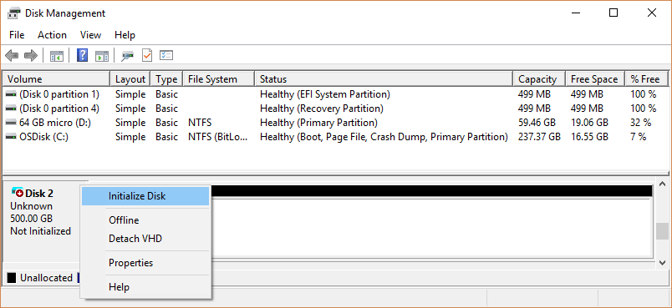

1. In the **Initialize Disk** dialog box (shown here), check to make sure that the correct disk is selected and then click **OK** to accept the default partition style. If you need to change the partition style (GPT or MBR) see [About partition styles - GPT and MBR](https://docs.microsoft.com/en-us/windows-server/storage/disk-management/initialize-new-disks#about-partition-styles---gpt-and-mbr).

The disk status briefly changes to **Initializing** and then to the **Online** status. If initializing fails for some reason, see [A disk's status is Not Initialized or the disk is missing entirely](https://docs.microsoft.com/en-us/windows-server/storage/disk-management/troubleshooting-disk-management#disks-that-are-missing-or-not-initialized-plus-general-troubleshooting-steps).

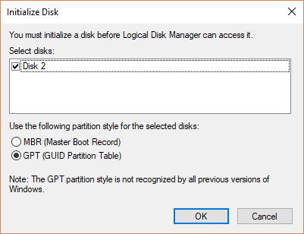

1. Select and hold (or right-click) the unallocated space on the drive and then select **New Simple Volume**.
2. Select **Next**, specify the size of the volume (you'll likely want to stick with the default, which uses the whole drive), and then select **Next**.
3. Specify the drive letter you want to assign to the volume and then select **Next**.
4. Specify the file system you want to use (usually NTFS), select **Next**, and then **Finish**.

**5.3.2 Disk formatting**

Disk formatting is the configuring process of a data storage media such as a hard disk drive, floppy disk or flash drive for initial usage. Any existing files on the drive would be erased with disk formatting. Disk formatting is usually done before initial installation or before installation of a new operating system. Disk formatting is also done if there is a requirement for additional storage in the computer.

The formatting comprises low-level formatting, partitioning and high-level formatting. Low-level formatting aids in preparing the physical structure on the storage media. The partitioning process involves the division of the hard drive into logical volumes for data storage. High-level formatting helps in creating the file system format within the logical volume or within the disk partition. Disk formatting is usually done with the help of a disk formatting utility.

While preparing the hard drive for initial use, disk formatting checks for errors in the drive. It can scan and repair bad sectors. Another benefit associated with disk formatting is its capability to erase bad applications and remove sophisticated viruses.

Disk formatting is an action which must be done with caution. As it deletes data and removes programs installed, backup of the necessary data or applications are required. Disk formatting takes time. Frequent disk formatting can gradually decrease the life of a hard drive.

**How to Format Disk**

When you're dealing with a drive that already has a partition, you can format the existing partition to delete its files and start with a clean storage.

To format a partition using Disk Management, use these steps:

1. Open **Start**.
2. Search for **Create and format hard disk partitions** and click the top result to open the **Disk Management** console.
3. Right-click the new hard drive and select the **Format** option.

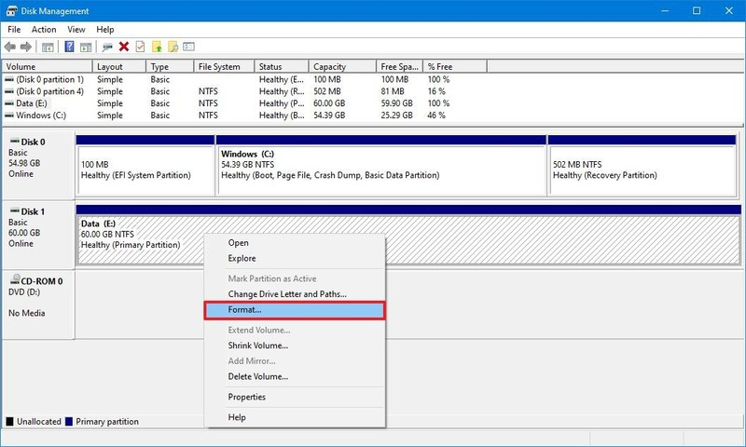*Source: Windows Central*

1. In the "Value label" field, confirm a new name for the storage.
2. Use the "File system" drop-down menu, and select the **NTFS** option (recommended for Windows 10).
3. Use the "Allocation unit size" drop-down menu, and select the **Default** option.
4. Check the **Perform a quick format** option.

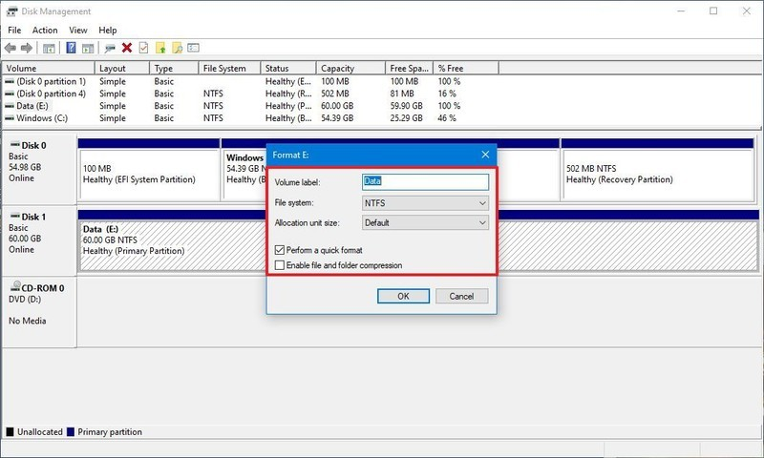

1. Clear the **Enable file and folder compression** option.
2. Click the **OK** button.
3. Click the **OK** button again.

Once you complete the steps, the tool will format the selected partition on the drive, and then you can begin storing files.

**6.0 COMPUTER SECURITY**

**Computer security**, also known as **cybersecurity** or **IT security**, is the protection of information systems from theft or damage to the hardware, the software, and to the information on them, as well as from disruption or misdirection of the services they provide. It includes controlling physical access to the hardware, as well as protecting against harm that may come via network access, data and code injection, and due to malpractice by operators, whether intentional, accidental, or due to them being tricked into deviating from secure procedures.

**6.1 COMPUTER ROOM SAFETY**

Computer room is a building where computers are kept for staffs and students to use in an organization. Health and safety in a computer room is very important as the misuse of the computer room may lead to certain problems both physically and mentally. Using a computer for a long period of time can affect your health in different ways. Many such incidents in a data center are the result of accidents that could be avoided by following some simple safety rules.

### **6.2 Computer Laboratory Rules and Regulations**

Do’s

1. Know the location of the fire extinguisher and the first aid box and how to use them in case of an emergency.

2. Read and understand how to carry out an activity thoroughly before coming to the laboratory.

3. Report fires or accidents to your lecturer/laboratory technician immediately.

4. Report any broken plugs or exposed electrical wires toyour lecturer/laboratory technician immediately.

5. Benches and desks must be strong enough to support the computers

6. There must be adequate space around the machine

**Don’ts**

1. Do not eat or drink in the laboratory.

2. Avoid stepping on electrical wires or any other computer cables.

3. Do not open the system unit casing or monitor casing particularly when the power is turned on. Some internal components hold electric voltages of up to 30000 volts, which can be fatal.

4. Do not insert metal objects such as clips, pins and needles into the computer casings. They may cause fire.

5. Do not remove anything from the computer laboratory without permission.

6. Do not touch, connect or disconnect any plug or cable without your lecturer/laboratory technician’s permission.

7. Do not misbehave in the computer laboratory.

8. Computer games are prohibited

9. Eating and drinking in computer rooms are prohibited

## ****6.3 Safety measures to be taken are:****

## These are the precaution that computer professionals should be aware of when using the computer to avoid health problems and accidents.

1. Good ventilation: The need for air conditioner or fan is necessary for the computer user to be comfortable.
2. Setting computers: When setting a computer room the following must be taken:The computer must be space apart, free entry and exit, computer library should be close to the computer room.
3. Dust free environment: Dust should be prevented as often as possible in the computer. The floor must always be kept clean , the computer and it’s peripheral should be covered using the dust cover after use.
4. Protection from power problems: The surge protectors, the use of stabilizer and UPS(Uninterrupted Power Supply) must be upheld to prevent any damage caused by power fluctuations.
5. Good lightening: The computer room should be well illuminated, use of LED( Lead emitter display) bulbs should be used to provide light to make the room bright for all the activities carried out.
6. Keeping liquid away from the computer room.

**6.4 MALWARE**

Malware, short for malicious software, is a blanket term for viruses, worms, trojans and other harmful computer programs hackers use to wreak destruction and gain access to sensitive information. Malware is a catch-all term for any type of malicious software designed to harm or exploit any programmable device, service or network. In other words, software is identified as malware based on its intended use, rather than a particular technique or technology used to build it.

## 6.4.1 TYPES OF MALWARE

## 1. Viruses

A virus usually comes as an attachment in an email that holds a virus payload, or the part of the malware that performs the malicious action. Once the victim opens the file, the device is infected.

## 2. Worms

Worms have the ability to copy themselves from machine to machine, usually by exploiting some sort of security weakness in a software or operating system and don’t require user interaction to function.

The distinctive trait of the [computer worm](https://www.csoonline.com/article/3429569/what-is-a-computer-worm-how-this-self-spreading-malware-wreaks-havoc.html) is that it's self-replicating. Take the notorious [Iloveyou worm](http://en.wikipedia.org/wiki/ILOVEYOU): When it went off, it hit nearly every email user in the world, overloaded phone systems (with fraudulently sent texts), brought down television networks, and even delayed my daily afternoon paper for half a day. Several other worms, including [SQL Slammer](http://www.infoworld.com/t/malware/exorcizing-the-ghost-slammer-492) and [MS Blaster](http://en.wikipedia.org/wiki/Blaster_(computer_worm)), ensured the worm's place in computer security history.

## 3. Trojans

Trojans masquerade as harmless applications, tricking users into downloading and using them. Once up and running, they then can steal personal data, crash a device, spy on activities or even launch an attack.Trojans are hard to defend against for two reasons: They're easy to write ([cyber criminals routinely produce and hawk Trojan-building kits](http://www.infoworld.com/d/security/malware-and-hackers-increasingly-targeting-macs-780)) and spread by tricking end-users — which a patch, firewall, and other traditional defense cannot stop. Malware writers pump out Trojans by the millions each month. Antimalware vendors try their best to fight Trojans, but there are too many signatures to keep up with.

## 4. Ransomware

One of the most profitable, and therefore one of the most popular, types of malware amongst cybercriminals is ransomware. This malware installs itself onto a victim’s machine, encrypts their files, and then turns around and demands a ransom (usually in Bitcoin) to return that data to the user.

Malware programs that encrypt your data and hold it as hostage waiting for a cryptocurrency pay off has been a huge percentage of the malware for the last few years, and the percentage is still growing. [Ransomware](https://www.csoonline.com/article/3236183/ransomware/what-is-ransomware-how-it-works-and-how-to-remove-it.html) has often crippled companies, hospitals, police departments, and [even entire cities](https://www.cnn.com/2018/03/27/us/atlanta-ransomware-computers/index.html).

## 5. Fileless malware

## Fileless malware is a type of malicious software that uses legitimate programs to infect a computer. Fileless malware registry attacks leave no malware files to scan and no malicious processes to detect. It does not rely on files and leaves no footprint, making it challenging to detect and remove.

## 6. Adware

## Adware programs push unwanted advertisements at users and typically display blinking advertisements or pop-up windows when you perform a certain action. Adware programs are often installed in exchange for another service, such as the right to use a program without paying for it.

## 7. Malvertising

Not to be confused with adware, [malvertising](https://www.csoonline.com/article/3373647/what-is-malvertising-and-how-you-can-protect-against-it.html) is the use of legitimate ads or ad networks to covertly deliver malware to unsuspecting users’ computers. For example, a cybercriminal might pay to place an ad on a legitimate website. When a user clicks on the ad, code in the ad either redirects them to a malicious website or installs malware on their computer. In some cases, the malware embedded in an ad might execute automatically without any action from the user, a technique referred to as a “drive-by download.”

Cybercriminals have also been known to compromise legitimate ad networks that deliver ads to many websites. That’s often how popular websites such as the New York Times, Spotify and the London Stock Exchange have been vectors for malicious ads, putting their users in jeopardy.

The goal of cybercriminals who use malvertising is to make money, of course. Malvertising can deliver any type of money-making malware, including ransomware, cryptomining scripts or banking Trojans.

## 8. Spyware

Spyware is a program installed on your computer, usually without your explicit knowledge, that captures and transmits personal information or Internet browsing habits and details to its user. Spyware enables its users to monitor all forms of communications on the targeted device. Spyware is often used by law enforcement, government agencies and information security organizations to test and monitor communications in a sensitive environment or in an investigation. But spyware is also available to consumers, allowing purchasers to spy on their spouse, children and employees.

[Spyware](https://www.csoonline.com/article/3384100/what-is-spyware-how-it-works-and-how-to-prevent-it.html) is most often used by people who want to check on the computer activities of loved ones. Of course, in targeted attacks, criminals can use spyware to log the keystrokes of victims and gain access to passwords or intellectual property.

Adware and spyware programs are usually the easiest to remove, often because they aren't nearly as nefarious in their intentions as other types of malware.

**10. Scareware**

Cybercriminals scare us into thinking that our computers or smartphones have become infected to convince victims to purchase a fake application. In a typical scareware scam, you might see an alarming message while browsing the Web that says “Warning: Your computer is infected!” or “You have a virus!” Cybercriminals use these programs and unethical advertising practices to frighten users into purchasing rogue applications.

**6.4.2 SYMPTOMS OF MALWARE**

A computer virus attack can produce a variety of symptoms. Here are some of them:

* **Frequent pop-up windows.** Pop-ups might encourage you to visit unusual sites. Or they might prod you to download antivirus or other software programs.
* **Changes to your homepage.** Your usual homepage may change to another website, for instance. Plus, you may be unable to reset it.
* **Mass emails being sent from your email account.** A criminal may take control of your account or send emails in your name from another infected computer.
* **Frequent crashes.** A virus can inflict major damage on your hard drive. This may cause your device to freeze or crash. It may also prevent your device from coming back on.
* **Unusually slow computer performance.** A sudden change of processing speed could signal that your computer has a virus.
* **Unknown programs that start up when you turn on your computer.** You may become aware of the unfamiliar program when you start your computer. Or you might notice it by checking your computer’s list of active applications.
* **Unusual activities like password changes.** This could prevent you from logging into your computer.

**6.4.3 MALWARE PREVENTION**

To prevent your devices from being infected with malware, there are a number of steps you can take:

**1. Install Anti-virus software**

One of the most important ways to protect against malware is to install [anti-virus software](https://uk.pcmag.com/antivirus-reviews/8141/guide/the-best-antivirus-protection-of-2018). Anti-virus software will protect your device from malicious software that poses a threat to the system. It will scan your computer to detect and clean the malware and provide automatic updates to provide enhanced protection against newly created viruses.

**2. Regularly update software**

In addition to installing anti-virus software, it’s vital to ensure that your software is regularly updated to stop attackers gaining access to your computer through vulnerabilities in older and outdated systems.

**3. Only buy Apps from trusted sources**

Buying apps from trustworthy sources reduces the chance of your device being infected with malware. Big brands will take great care to ensure they do not damage their reputation by distributing malware. To check the authenticity of a source, you can check the full name, list of published apps and contact details in the app description within the Google Play or Apple app store.

**4. Don’t click on suspicious links or download attachments from unknown sources**

[Phishing](https://www.metacompliance.com/blog/what-to-do-if-you-click-on-a-phishing-link/) remains the easiest way for hackers to install malware on your device. [Phishing scams](https://www.metacompliance.com/blog/top-5-phishing-scams/) trick people into opening emails or clicking on a link that may appear to come from a legitimate business or reputable source. The link may direct you to a fake website where you are prompted to enter your personal details or take you to a website that directly infects your computer with malware. If in doubt, don’t click the link.

**5. Install Firewall**

Another way to protect your device from malware is to use a [firewall](https://www.techradar.com/uk/news/best-firewall). A firewall prevents malicious attacks by blocking all unauthorised access to or from a private computer network. In addition to anti-virus software, a firewall provides an extra barrier against malware, reducing the chance of attack.

**6. Back up data regularly**

It’s important to back up on a regular basis to ensure that you can still retrieve all your valuable data and files if your computer is infected with malware. This will help mitigate any damage and ensure that you are not held victim to a ransomware attack.

 Phishing is the number one cause of all cyber-attacks and continues to prove one of the easiest ways to steal valuable data and deliver malware. [MetaPhish](https://www.metacompliance.com/products/phishing-and-ransomware/) has been created to provide a powerful defence against these threats and enables organisations to find out just how susceptible their company is to phishing. If you would like to find out more about how MetaPhish can be used to [protect your business](https://www.metacompliance.com/resources/online-demo/), then contact us for further information.

### **7. Use secure authentication methods.**

* Require strong passwords with at least eight characters, including an uppercase letter, a lowercase letter, a number and a symbol in each password.
* Enable multi-factor authentication, such as a PIN or security questions in addition to a password.
* Use biometric tools like fingerprints, voiceprints, facial recognition and iris scans.
* Never save passwords on a computer or network. Use a secure password manager if needed.

### **8. Keep software updated.**

No software package is completely safe against malware. However, software vendors regularly provide patches and updates to close whatever new vulnerabilities show up. As a best practice, validate and install all new software patches:

* Regularly update your operating systems, software tools, browsers and plug-ins.
* Implement routine maintenance to ensure all software is current and check for signs of malware in log reports.

### **9. Educate your users.**

At the end of the day, people are the best line of defense. By continually educating users, you can help reduce the risk that they will be tricked by phishing or other tactics and accidentally introduce malware into your network. In particular:

* Build awareness of common malware attacks.
* Keep users up to date on basic cybersecurity trends and best practices.
* Teach users how to recognize credible sites and what to do if they stumble onto a suspicious one.
* Encourage users to report unusual system behavior.
* Advise users to only join secure networks and to use VPNs when working outside the office.

# **6.5 HOW TO INSTALL AN ANTIVIRUS PROGRAM ON A COMPUTER**

Antivirus programs help prevent [viruses](https://www.computerhope.com/jargon/v/virus.htm) and [spyware](https://www.computerhope.com/jargon/s/spyware.htm) from infecting a computer and therefore are one of the essential software programs each computer should have running at all times.

To install an antivirus program on your computer, follow the steps below.

1. If you purchased the antivirus program from a retail store, insert the [CD](https://www.computerhope.com/jargon/c/compactd.htm) or [DVD](https://www.computerhope.com/jargon/d/dvd.htm) into the computer's disc drive. The installation process should start automatically, with a window opening to help guide you through the install process.
2. If you [downloaded](https://www.computerhope.com/jargon/d/download.htm) the antivirus program on the Internet, find the downloaded file on your computer. If the downloaded file is a zip file, [unzip](https://www.computerhope.com/jargon/u/unzip.htm) the file to extract and access the installation files. Look for a file named **setup.exe**, **install.exe**, or something similar, then [double-click](https://www.computerhope.com/jargon/d/doublecl.htm) that file. The installation process should start, with a window opening to help guide you through the install process.
3. In the installation process window, follow the steps provided to install the antivirus program. The install process provides recommended options so the antivirus program will function properly, which in most cases can be accepted as is. The one exception is if the install process recommends to install any toolbars for Internet browsers or other helpful programs for your computer. If prompted to install other software along with the antivirus program, uncheck all boxes or decline the install of those extra programs. No additional programs should be needed for the antivirus program to install and run successfully on your computer.
4. When the install process is complete, close out of the install window.
5. If used, remove the CD or DVD from the computer's disc drive.

The antivirus program is now installed and ready to use. While it may not be required, we recommend [restarting](https://www.computerhope.com/jargon/r/reboot.htm) your computer so that any modified settings in the operating system can take effect correctly.

**6.6 DATA CONTROL**

Data security controls keep sensitive information safe and act as a countermeasure against unauthorized access. They enable [risk management](https://reciprocitylabs.com/product/risk-management/) programs by counteracting, detecting, minimizing, or avoiding security risks to computer systems, data, software, and networks.

### **DATA CONTROL TECHNIQUES**

### 1**. Authentication and Identity**

Authentication of users may take several forms like a password, a security token, or some measurable quality that is intrinsic to them, such as a fingerprint. Single-factor authentication is based only on one authentication factor, whereas, [multiple-authentication-factor (MAF)](https://www.cloudcodes.com/blog/multi-factor-authentication-in-office-365.html) is usually a secure two-step identity authentication like the use of a password and a one-time password (OTP) SMS. Federated-Identity-Management OR FIM could efficiently be utilized by more than one firm, which allows subscribers to use the same identification for obtaining access to all the networks of the group enterprises. Then, there is the [Single sign-on](https://www.cloudcodes.com/solutions/single-sign-on-for-cloud-security.html) (SSO), which lets the user login to multiple applications while authenticating only once.

### **2. Access Control Techniques**

The access Control mechanism is the key, wherein maintaining a complex IT environment becomes easy that supports the separation and integrity of different levels. It, together with other cloud security protocols, work towards securing the [cloud data](https://www.cloudcodes.com/blog/automation-giant-secure-its-cloud-data-with-aim-by-cloudcodes-casb.html). The most common types of this technique are as follows for data protection:

* **Discretionary Access Control (DAC)**: In this, the owner of the object decides who will have access and the privileges they will have.
* **Role-Based Access Control (RBAC)**: Here, the access policy is determined by the system, and a subject can access a particular document or file or execute a function only if their set of permissions or role allows it.
* **Mandatory Access Control (MAC)**: In this, the Operating system constrains the ability of the user to access or execute the function on an object. Whenever any of the users try accessing the purpose, the OS kernel would examine security attributes and then grant access.

These three access controls, though fundamentally different, can be combined in various ways to give multi-level security to the cloud data.

### **3. Data categorization and use of Data labels**

For adequate data protection controls to be put in place, the nature of information is to be understood first. So the valuable data has to be categorized as to what is sensitive and what can be accessed. After the data identification and categorization, cloud security strategies can be implemented on it. Data can be categorized and labeled as unclassified, confidential, secret, top-secret, or compartmented. Labeling also helps in segregating categories such as finance, business, HR, IT, and so on. There has to be a balance in managing sensitive information and sound strategies for protecting the data.

### **4. Encryption for Data at Rest and in Motion**

Secure encryption forms a pivotal strategy to [protect the data at rest](https://www.cloudcodes.com/blog/is-your-data-at-rest-safe.html) in the cloud, particularly for the data which has continuing value for an extended period.

### **5. Deletion of Data**

 It is essential to know how the data is deleted in cloud security.

* **Clearing**: Here, the data on the media is eradicated before reusing the media and, at the same time, providing an acceptable level of protection for the information that was in the press before clearing.
* **Sanitization**: Here, an acceptable level of protection to the previous data is not provided. Such type of information is usually released for use at a lower classification level. Very often, the cloud data is not sanitized to the DoD level with the risk of the data getting exposed.
* **Data Masking**: This technique involves removing all the identifiable and distinguishable characteristics from the data to render it anonymous and still be operable.

**6.7 COMPUTER SYSTEM AUDITING**

Computer auditing is a systematic and logical process that follows a risk based approach to determine whether the information systems of an entity, including its detailed information technology processes, controls and activities, will achieve its IT objectives and will thereby ultimately enable the organization to achieve their organizational goals. Computer systems auditing involves series of designing and monitoring of control systems, which ensure the accuracy and security of data. It also involves a review of an organization’s computing environment and the use of their computer facilities. Computer systems auditing provide managers with expert opinions about the reliability of results and operations of computer systems.

How to perform computer system auditing

## 1.    Review

In this phase, the system auditor tries to comprehend the management practices and various functions used at multiple levels of the IT hierarchy. This step determines whether or not the auditor will proceed with the rest of the rest.

Tasks such as observing installation procedures, interviewing installation staff, and going through installation documentation take place. Additional reviewing is carried out for the management and application controls; crucial weaknesses are identified in the management controls. Auditors also try to determine if the measures implemented in the installation controls are sufficient to bring down losses to an acceptable level.

## 2.    System Vulnerability is Assessed

In the next step of the audit, different applications are individually assessed to find out the most vulnerable ones. Computer systems and applications that are the most vulnerable are also the ones used for abuse. Hence, the type of application and the control of quality protocols are reviewed.

## 3.    Threats are Identified

Information systems are threatened by external and internal users such as programmers, system analysts, regular users, cyber security specialists, data entry operators, software services, data vendors, etc. All such people are identified by system auditors.

In the same way, events, points, and occasions are found out when the IT infrastructure was breached earlier. It can be when a transaction was carried out that might have been deleted, added or altered. There’s also the possibility of risky behavior when data or programs are edited or when their operation is at fault.

## 4.    Internal Controls are analyzed

In this step, system auditors determine the efficacy of the information system’s internal controls and whether or not they are working the way they should. They also check any missing internal controls within the system.

## 5.    Final Evaluation

In the last step of the system audit, different tests are carried out for the various components of the internal control systems of the organization. The main purpose of this phase is to calculate the probability of any future losses in assets. These tests include identifying erroneous processing, assessing the data quality, finding out inaccurate data, comparing physical counts of data, and confirming data with external sources

# **Computer Ergonomics**

Computer ergonomics is the study of how we interact with our computers. Scientists that study computer ergonomics, attempt to find solutions to strain, fatigue, and injuries caused by poor product design or workplace arrangement. Their goal is to create an overall comfortable and relaxed workplace environment.

Sitting at a computer for many hours a day, many people find themselves looking for a better way to work. Personally, my back hurts, my neck gets tight, and I often find that my legs fall asleep. So what can you do when your workstation is ergonomically wrong?

**Setting Up Your Workstation**

According to the ergonomic experts at the [University of Michigan](https://www.uhs.umich.edu/computerergonomics), your workstation should

* Be adjusted to allow your arms to rest at a 90-degree angle to the keyboard
* Allow for the monitor and keyboard to be separated
* Have a chair that supports your back in an upright seated position with a slight arch that may or may not contain a lumbar roll for the lower back
* Position the monitor to be directly in front of you (at least 18 inches) and at eye level
* Keep feet flat on the floor with the legs in a parallel position, and for the vertically challenged, a footrest may be needed
* If using a hard-copy document, use a document holder to keep it at eye level

**Other Factors to Consider**

* Other factors such as body position, working for shorter periods of time before moving around, and moving every 10 minutes, will help keep your back and neck from becoming stiff and sore. One study reported that workers who moved every seven minutes avoided computer-related pain, even with extended computer use. Every 30 minutes to an hour, take a short break to get up out of your chair and stretch or walk around.
* Keeping physically fit can also help to avoid, and even treat, problems and pains related to extended computer use. Build up core muscles to support the lower back while seated.
* If you have constant pain, numbness, or any other symptoms that are persistent and do not go away, seek medical care immediately. A delay in seeking care may cause the problems to develop into serious medical conditions related to the back and joints.

# **7.0 COMPUTER NETWORK**

A computer network is a group of computers linked to each other that enables the computer to communicate with another computer and share their resources, data, and applications.

**7.1 TYPES OF NETWORK**

A computer network can be categorized by their size. A **computer network** is mainly of **four types**:

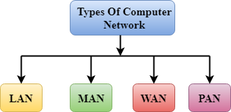

* LAN(Local Area Network)
* PAN(Personal Area Network)
* MAN(Metropolitan Area Network)
* WAN(Wide Area Network)

## LAN(Local Area Network)

* Local Area Network is a group of computers connected to each other in a small area such as building, office.
* LAN is used for connecting two or more personal computers through a communication medium such as twisted pair, coaxial cable, etc.
* It is less costly as it is built with inexpensive hardware such as hubs, network adapters, and ethernet cables.
* The data is transferred at an extremely faster rate in Local Area Network.
* Local Area Network provides higher security.

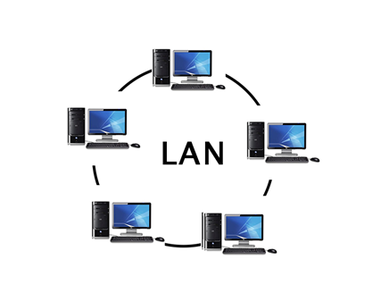

**Components of LAN:**

A LAN is made up of three basic elements:

* A. The hardware which is connected to form the LAN.
* B. The software (or programs) which is accessed through the LAN.
* C. The users, who create, work with and manage the various files.

Each of these elements can be divided into a number of components.

**A. Hardware Components:**

A LAN can be thought of as a system composed of a series of building blocks. These blocks can be added and configured as needed. Some of basic hardware components of LAN’s are:

**1. Networking Interface Card (NICs):**

A network interface card (NIC) is a circuit board or card that is installed in a computer so that it can be connected to a network. Each networked device contains a Network Interface Card. The NIC may be a separate board installed into a computer’s slot, or it may be built into the motherboard.  
**2. Server:**

A network server is a computer designed to process requests and deliver data to other (client) computers over a local network or the Internet. A server may be three types:

* **File Server:** A file server is a computer that stores files, is attached to a network, and provides shared access of those files to multiple workstation computers.
* **Print Server:** A print server is a device that connects printers to client computers over a network. It accepts print request from the computers and sends the jobs to the appropriate printers over the LAN.
* **Communication Server:** A communication server is a computer system designed to handle a wide range of communications-based applications.

**3. Station:**

A station is a computer that is connected with a server computer over the LAN, and communicate with other devices connected with it.

**4. HUB:**

A common connection point for devices in a network. Hubs are commonly used to connect segments of a LAN. A hub contains multiple ports. When a packet arrives atone port, it is copied to the other ports so that all segments of the LAN can see all-packets.

**5. Switch:**

A switch is like a hub in that it is a central point for connecting network cables; however, a switch is able to receive a packet and transmit it to only the destination computer.

**6. Router:**

Routers make the connection to the Internet for LANs. They use a configuration table to decide where packets should go.

**7. Access point:**

A hardware device or a computer’s software that acts as a communication hub for users of a wireless device to connect to a wired LAN.

**8. Power Supply:**

Both wired and wireless networks need a power supply. A wireless network uses the current to generate radio waves. A cabled network sends data interpreted as an electronic pulse.

**9. Connector:**

A network connector refers to any device that used to connect many LAN connection with the hardware of the computer.

**10. Shared Peripheral Device:**

A peripheral device is any device—such as a printer, hard disk drive, CD-ROM drive or modem—that is connected to and controlled by a computer. Any or all of these devices can be accessed by multiple users when connected to a LAN in the proper manner.

**B. LAN Software:**

Once the physical building blocks of the LAN are put into place, the next step is to make them functional. Software is needed for devices to function cooperatively and effectively on the LAN. There are three categories of software found on a LAN:

* **The operating system of each attached server:** The server operating system is considered to be the brains of the network:
* **The operating system of each attached station:** All PCs require an operating system to function.
* **Applications software accessed by LAN users:** Applications software is those software, which are used to perform a specific task. The most common business applications are word processing, spreadsheet analysis and database management.

**Groupware:** A second type of application software has been introduced for the LAN environment— groupware. Groupware refers to programs that help people work together collectively while located remotely from each other.

**Client/server computing:** In client/ server computing, the applications software is created and sold for use expressly on a LAN. Client/server software has two distinct parts—the client part which runs on the user’s station and the server part which is installed on the file server.

**C. The People:**

Among the most important elements of a LAN are the people. The purpose of a LAN is to allow the sharing of resources. This sharing is done by people—making them an integral part of the structure.

With any LAN there are two groups of people involved—those who use the resources and those who manage the resources.

* **The users:** A user is defined as a person who makes use of the network resources.
* **Network Administrator:** The network administrator is the individual responsible for maintaining the LAN. It is essential that the administrator have a good understanding of how the network is put together and how it functions.

A LAN consists of a group of computers and devices connected by switches and hubs. For this LAN to gain access to the Internet it must contain a router. The speed of the network greatly depends on the configuration of the switches and hubs.

## PAN(Personal Area Network)

* Personal Area Network is a network arranged within an individual person, typically within a range of 10 meters.
* Personal Area Network is used for connecting the computer devices of personal use is known as Personal Area Network.
* **Thomas Zimmerman** was the first research scientist to bring the idea of the Personal Area Network.
* Personal Area Network covers an area of **30 feet**.
* Personal computer devices that are used to develop the personal area network are the laptop, mobile phones, media player and play stations.

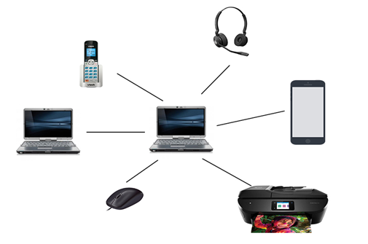

**There are two types of Personal Area Network:**

* Wired Personal Area Network
* Wireless Personal Area Network

**Wireless Personal Area Network:** Wireless Personal Area Network is developed by simply using wireless technologies such as WiFi, Bluetooth. It is a low range network.

**Wired Personal Area Network:** Wired Personal Area Network is created by using the USB.

### Examples Of Personal Area Network:

* **Body Area Network:** Body Area Network is a network that moves with a person. **For example**, a mobile network moves with a person. Suppose a person establishes a network connection and then creates a connection with another device to share the information.
* **Offline Network:** An offline network can be created inside the home, so it is also known as a **home network**. A home network is designed to integrate the devices such as printers, computer, television but they are not connected to the internet.
* **Small Home Office:** It is used to connect a variety of devices to the internet and to a corporate network using a VPN

## MAN(Metropolitan Area Network)

* A metropolitan area network is a network that covers a larger geographic area by interconnecting a different LAN to form a larger network.
* Government agencies use MAN to connect to the citizens and private industries.
* In MAN, various LANs are connected to each other through a telephone exchange line.
* The most widely used protocols in MAN are RS-232, Frame Relay, ATM, ISDN, OC-3, ADSL, etc.
* It has a higher range than Local Area Network(LAN).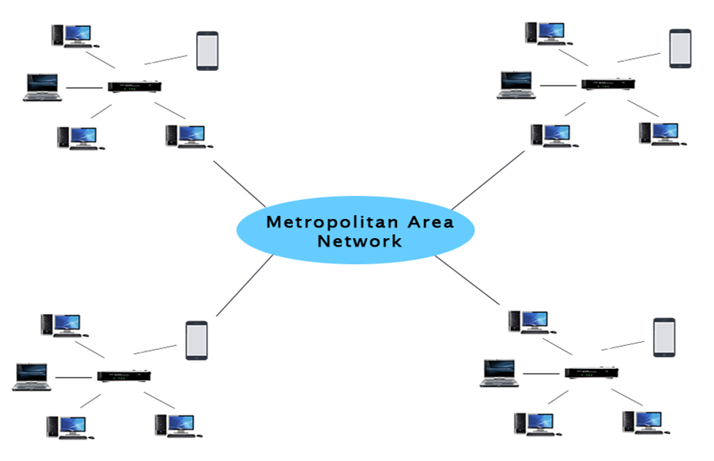

### **Uses Of Metropolitan Area Network:**

* MAN is used in communication between the banks in a city.
* It can be used in an Airline Reservation.
* It can be used in a college within a city.
* It can also be used for communication in the military.

## WAN(Wide Area Network)

* A Wide Area Network is a network that extends over a large geographical area such as states or countries.
* A Wide Area Network is quite bigger network than the LAN.
* A Wide Area Network is not limited to a single location, but it spans over a large geographical area through a telephone line, fibre optic cable or satellite links.
* The internet is one of the biggest WAN in the world.
* A Wide Area Network is widely used in the field of Business, government, and education.

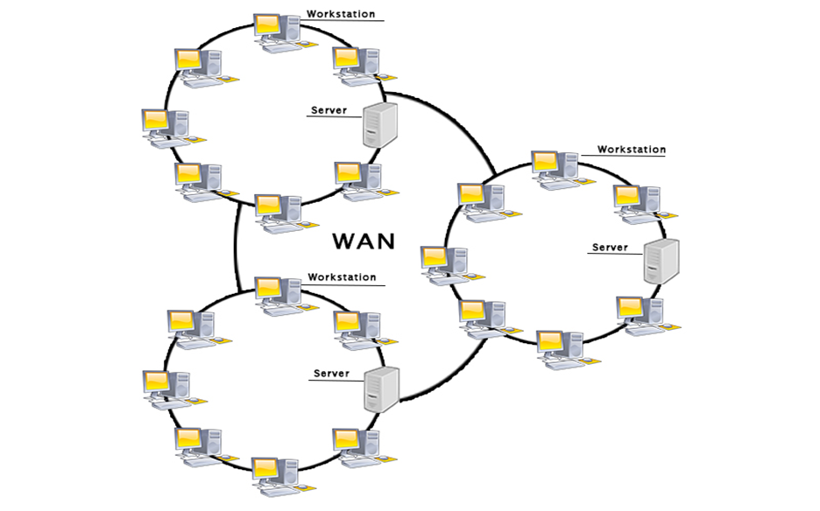

### **Examples of Wide Area Network:**

* **Mobile Broadband:** A 4G network is widely used across a region or country.
* **Last mile:** A telecom company is used to provide the internet services to the customers in hundreds of cities by connecting their home with fiber.
* **Private network:** A bank provides a private network that connects the 44 offices. This network is made by using the telephone leased line provided by the telecom company.

## Internetwork

* An internetwork is defined as two or more computer network LANs or WAN or computer network segments are connected using devices, and they are configured by a local addressing scheme. This process is known as **internetworking**.
* An interconnection between public, private, commercial, industrial, or government computer networks can also be defined as **internetworking**.
* An internetworking uses the **internet protocol**.
* The reference model used for internetworking is **Open System Interconnection(OSI)**.

## Types of Internetwork:

1. **Extranet:** An extranet is a communication network based on the internet protocol such as **Transmission Control protocol** and **internet protocol**. It is used for information sharing. The access to the extranet is restricted to only those users who have login credentials. An extranet is the lowest level of internetworking. It can be categorized as **MAN**, **WAN** or other computer networks. An extranet cannot have a single **LAN**, atleast it must have one connection to the external network.

2. **Intranet:** An intranet is a private network based on the internet protocol such as **Transmission Control protocol** and **internet protocol**. An intranet belongs to an organization which is only accessible by the **organization's employee** or members. The main aim of the intranet is to share the information and resources among the organization employees. An intranet provides the facility to work in groups and for teleconferences.

## Intranet advantages:

* **Communication:** It provides a cheap and easy communication. An employee of the organization can communicate with another employee through email, chat.
* **Time-saving:** Information on the intranet is shared in real time, so it is time-saving.
* **Collaboration:** Collaboration is one of the most important advantage of the intranet. The information is distributed among the employees of the organization and can only be accessed by the authorized user.
* **Platform independency:** It is a neutral architecture as the computer can be connected to another device with different architecture.
* **Cost effective:** People can see the data and documents by using the browser and distributes the duplicate copies over the intranet. This leads to a reduction in the cost.

**7.2 IMPORTANCE OF COMPUTER NETWORKING:**

There are several reasons why networking is essential to a business, institution or individual. These benefits include:

### **Cut back on costs**

Why are networks important? You can cut back on costs and allow for efficient use of resources. Hardware is the priciest resource in technology. Computer networks reduce your hardware costs significantly.  
Since the computers are interconnected, resource pooling is efficient. Printers, copiers and backup storages are shared among employees. This eliminates the need to buy single IT assets for each employee. Unlike traditional desktops, you don’t need frequent software installations. You only need to install updates and track performance.

### **Boost storage capacity and volume**

Computer networks pools their entire data to a central data storage server. This data is accessible to your employees. You can use the data to gain insights on how to boost your company’s productivity. With a central server, you lower the number of storage servers needed. And you increase the efficiency of operations.

### **Optimize convenience and flexibility**

Computer networks enable flexible operations. The data is not stored in a local server making it accessible with internet connectivity. You can access your data from any device. This enhances free movement while accessing your data wherever you may be.

### **Streamline communication**

Computer networking is a massive boon to the communication landscape. Networking allows you to send and receive text messages and files in real time. Information is available and easy to access from any device. You only need a reliable internet connection. Even if your device shuts down, you log in from a different device and access your data.

**7.3 NETWORK TOPOLGY**

**Network topology** refers to the manner in which the links and nodes of a **network** are arranged to relate to each other. Network topology refers to the physical arrangement of computers in a network.

## Types of Topology

1. Mesh Topology
2. Star Topology
3. Bus Topology
4. Ring Topology
5. Hybrid Topology
6. Tree Topology

## Mesh Topology

## A mesh topology is a network setup where each computer and network device is interconnected with one another. This topology setup allows for most transmissions to be distributed even if one of the connections goes down. It is a topology commonly used for [wireless networks](https://www.computerhope.com/jargon/w/wifi.htm). Below is a visual example of a simple computer setup on a network using a mesh topology.

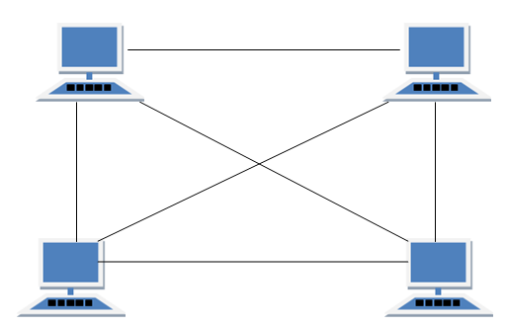

### **Advantages of Mesh topology**

* + 1. No data traffic issues as there is a dedicated link between two devices which means the link is only available for those two devices.
    2. Mesh topology is reliable and robust as failure of one link doesn’t affect other links and the communication between other devices on the network.
    3. Mesh topology is secure because there is a point to point link thus unauthorized access is not possible.
    4. Fault detection is easy.

### **Disadvantages of Mesh topology**

1. Amount of wires required to connected each system is tedious and headache.  
2. Since each device needs to be connected with other devices, number of I/O ports required must be huge.  
3. Scalability issues because a device cannot be connected with large number of devices with a dedicated point to point link.

## Star Topology

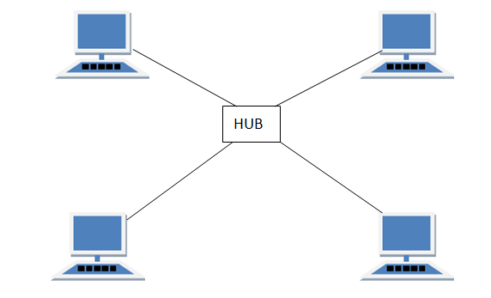  
In star topology each device in the network is connected to a central device called hub. Unlike Mesh topology, star topology doesn’t allow direct communication between devices, a device must have to communicate through hub. If one device wants to send data to other device, it has to first send the data to hub and then the hub transmit that data to the designated device.

### **Advantages of Star topology**

* 1. Less expensive because each device only need one I/O port and needs to be connected with hub with one link.
  2. Easier to install
  3. Less amount of cables required because each device needs to be connected with the hub only.
  4. Robust, if one link fails, other links will work just fine.
  5. Easy fault detection because the link can be easily identified.

### **Disadvantages of Star topology**

1. If hub goes down everything goes down, none of the devices can work without hub.  
2. Hub requires more resources and regular maintenance because it is the central system of star topology.

## Bus Topology

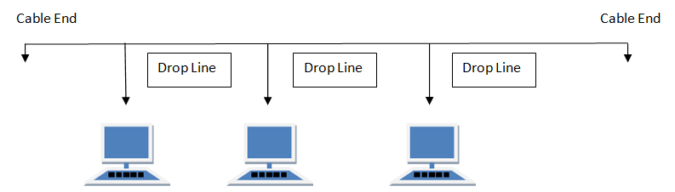  
In bus topology there is a main cable and all the devices are connected to this main cable through drop lines. There is a device called tap that connects the drop line to the main cable. Since all the data is transmitted over the main cable, there is a limit of drop lines and the distance a main cable can have.

### **Advantages of bus topology**

1.Easy installation, each cable needs to be connected with backbone cable.  
2. Less cables required than Mesh and star topology

### **Disadvantages of bus topology**

1. Difficultly in fault detection.

2. Not scalable as there is a limit of how many nodes you can connect with backbone cable.

## Ring Topology

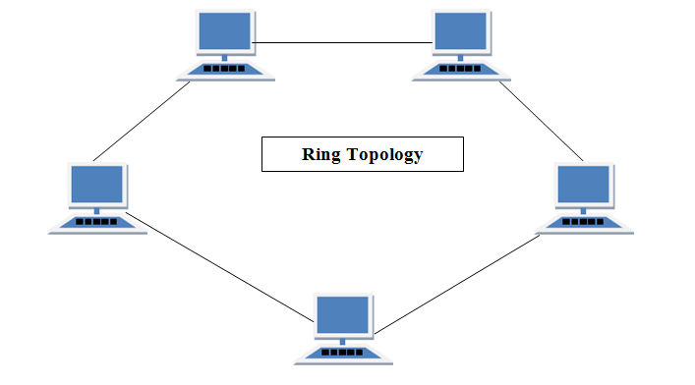  
In ring topology each device is connected with the two devices on either side of it. There are two dedicated point to point links a device has with the devices on the either side of it. This structure forms a ring thus it is known as ring topology. If a device wants to send data to another device then it sends the data in one direction, each device in ring topology has a repeater, if the received data is intended for other device then repeater forwards this data until the intended device receives it.

### **Advantages of Ring Topology**

* 1. Easy to install.
  2. Managing is easier as to add or remove a device from the topology only two links are required to be changed.

### **Disadvantages of Ring Topology**

1. A link failure can fail the entire network as the signal will not travel forward due to failure.  
2. Data traffic issues, since all the data is circulating in a ring.

## TREE Topology

It has a root node and all other nodes are connected to it forming a hierarchy. It is also called hierarchical topology. It should at least have three levels to the hierarchy.

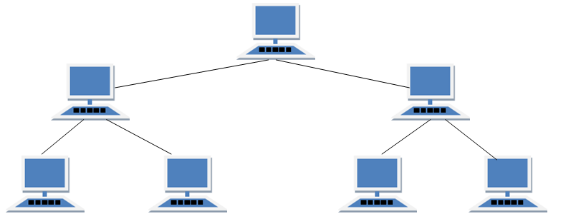

#### **Features of Tree Topology**

1. Ideal if workstations are located in groups.
2. Used in Wide Area Network.

#### **Advantages of Tree Topology**

1. Extension of bus and star topologies.
2. Expansion of nodes is possible and easy.
3. Easily managed and maintained.
4. Error detection is easily done.

#### **Disadvantages of Tree Topology**

1. Heavily cabled.
2. Costly.
3. If more nodes are added maintenance is difficult.
4. Central hub fails, network fails.

## HYBRID Topology

It is two different types of topologies which is a mixture of two or more topologies. For example if in an office in one department ring topology is used and in another star topology is used, connecting these topologies will result in Hybrid Topology (ring topology and star topology).

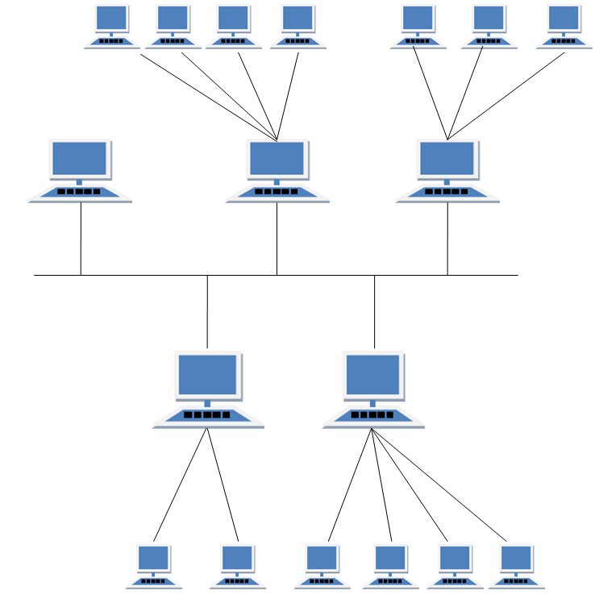

#### **Features of Hybrid Topology**

1. It is a combination of two or topologies
2. Inherits the advantages and disadvantages of the topologies included

#### **Advantages of Hybrid Topology**

1. Reliable as Error detecting and trouble shooting is easy.
2. Effective.
3. Scalable as size can be increased easily.
4. Flexible.

#### **Disadvantages of Hybrid Topology**

1. Complex in design.
2. Costly.

**8.0 INTERNET**

**Internet** is a **global network** of billions of computers and other electronic devices connected together to allow sharing of information and resources.

In order to connect to the Internet, you must have access to an Internet service provider (ISP), which acts the middleman between you and the Internet. Most ISPs offer [broadband](https://techterms.com/definition/broadband) Internet access via a [cable](https://techterms.com/definition/cable_modem), [DSL](https://techterms.com/definition/dsl), or [fiber](https://techterms.com/definition/fiber_optic_cable) connection. When you connect to the Internet using a public [Wi-Fi](https://techterms.com/definition/wi-fi) signal, the Wi-Fi router is still connected to an ISP that provides Internet access. Even cellular data towers must connect to an Internet service provider to provide connected devices with access to the Internet.

The terms internet and World Wide Web are often used interchangeably, but they are not exactly the same thing; the internet refers to the global communication system, including hardware and infrastructure, while the web is one of the services communicated over the internet

The Internet provides different [online](https://techterms.com/definition/online) services. Some examples include:

* [**Web**](https://techterms.com/definition/www) **–** A collection of billions of webpages that you can view with a web browser
* [**Email**](https://techterms.com/definition/email) **–** The most common method of sending and receiving messages online
* [**Social media**](https://techterms.com/definition/social_media) **–** websites and [apps](https://techterms.com/definition/app) that allow people to share comments, photos, and videos
* **Online gaming –** Games that allow people to play with and against each other over the Internet
* **Software updates –** [Operating System](https://techterms.com/definition/operating_system) and [application](https://techterms.com/definition/application) updates can typically [downloaded](https://techterms.com/definition/download) from the Internet

**8.1 HISTORY OF INTERNET**

As you might expect for a technology so expansive and ever-changing, it is impossible to credit the invention of the internet to a single person. [The internet](https://www.history.com/topics/inventions/invention-of-the-internet) was the work of dozens of pioneering scientists, programmers and engineers who each developed new features and technologies that eventually merged to become the “information superhighway” we know today.

Long before the technology existed to actually build the internet, many scientists had already anticipated the existence of worldwide networks of information. [Nikola Tesla](https://www.history.com/topics/inventions/nikola-tesla) toyed with the idea of a “world wireless system” in the early 1900s, and visionary thinkers like Paul Otlet and Vannevar Bush conceived of mechanized, searchable storage systems of books and media in the 1930s and 1940s.

Still, the first practical schematics for the internet would not arrive until the early 1960s, when MIT’s J.C.R. Licklider popularized the idea of an “Intergalactic Network” of computers. Shortly thereafter, computer scientists developed the concept of “packet switching,” a method for effectively transmitting electronic data that would later become one of the major building blocks of the internet.

The first workable prototype of the Internet came in the late 1960s with the creation of ARPANET, or the Advanced Research Projects Agency Network. Originally funded by the U.S. Department of Defense, ARPANET used packet switching to allow multiple computers to communicate on a single network.

On October 29, 1969, ARPAnet delivered its first message: a “node-to-node” communication from one computer to another. (The first computer was located in a research lab at UCLA and the second was at Stanford; each one was the size of a small house.) The message—“LOGIN”—was short and simple, but it crashed the fledgling ARPA network anyway: The Stanford computer only received the note’s first two letters.

The technology continued to grow in the 1970s after scientists Robert Kahn and Vinton Cerf developed Transmission Control Protocol and Internet Protocol, or TCP/IP, a communications model that set standards for how data could be transmitted between multiple networks.

ARPANET adopted TCP/IP on January 1, 1983, and from there researchers began to assemble the “network of networks” that became the modern Internet. The online world then took on a more recognizable form in 1990, when computer scientist Tim Berners-Lee invented the World Wide Web. While it’s often confused with the internet itself, the web is actually just the most common means of accessing data online in the form of websites and hyperlinks.

The web helped popularize the internet among the public, and served as a crucial step in developing the vast trove of information that most of us now access on a daily basis.

**8.2 BASIC TERMS USED IN INTERNET**

**Url**

Uniform Resource Locators—URLs—are the web browser addresses of internet pages and files. With a URL, you can locate and bookmark specific pages and files in a web browser. URLs may be listed at the bottom of business cards, on TV screens during commercial breaks, linked in documents you read on the internet, or delivered by one of the internet search engines.

The format of a [URL](https://www.lifewire.com/what-is-a-url-2626035) resembles this:

**http://www.examplewebsite.com/mypage**

This format is frequently shortened to this:

**www.examplewebsite.com/mypage**

Sometimes URLs are longer and more complicated, but all follow acknowledged rules for naming. URLs consist of three parts:

* **Protocol**: The [protocol](https://www.lifewire.com/hypertext-transfer-protocol-817944) is the portion ending in **//:**. Most web pages use the protocol http or https, but there are other protocols.
* **Host**: The host or top-level domain, which frequently ends in .com, .net, .edu, or .org but can also end in one of many others that have been officially recognized.
* **Filename**: The filename or page name.

**Domain**

While every computer has its own unique address, every user using the Internet has a unique address called a domain. A domain recognizes one or more IP addresses. An example of a domain is [weather.com](https://weather.com/) and is part of the **URL** such as [https://www.weather.com](https://weather.com/). The standard top-level domains are:

* **com -**Commercial business
* **edu -**Educational institutions
* **gov -**Government agencies
* **mil -**Military
* **net -**Networks organization
* **org -**Organizations (nonprofit)

There are additional top-level domains that are now recognized on the Internet. They include:

* **aero -**Air-transport industry
* **biz -**Businesses
* **coop -** Cooperatives
* **info -** Unrestricted use
* **museum -**museums
* **pro -** Accountants, lawyers, physicians, and other professionals
* **tv -**Television

Some countries use a sub-domain or geographical domain as part of their address. Fox example, an academic institution such as Oxford University in the United Kingdom can use ac.uk. An example of a URL with this domain is <http://www.ox.ac.uk/>.

**Browser**

A piece of software such as Mozilla Firefox and Internet Explorer that allows a computer to access and display documents, view pictures, hear sound, and view video clips from the World Wide Web.

**E-mail**

Mail that's electronically transmitted by your computer. As opposed to snail mail, e-mail sends your messages instantaneously, anywhere in the world. It has the capability to send messages at any time and to anyone.

**File Transfer Protocol (FTP)**

The standard method for downloading and uploading files over the Internet. With FTP, you can login to a server and transfer files (meaning you can "send" or "receive" files).

**Homepage**

The first page that is viewed when the browser starts. It is also the page of a Web site that provides the introduction or content with links.

**Hypertext Transfer Protocol (HTTP)**

The abbreviation for Hypertext Transfer Protocol. It is the set of rules by which Web pages are transferred across the Internet.

[HTTP](https://www.lifewire.com/what-do-http-and-https-stand-for-3482375) is the data communication standard of web pages. When a web page has this prefix, the links, text, and pictures should work correctly in a web browser.

HTTPS is the acronym for Hypertext Transfer Protocol Secure. This indicates that the web page has a special layer of encryption added to hide your personal information and passwords from others. Whenever you log in to your online bank account or a shopping site that you enter credit card information into, look for **https** in the URL for security.

**Internet Protocol (IP) Address**

The Internet is composed of local, regional, national, and worldwide computer networks. Each computer on the Internet can be identified by a set of unique numbers that is called an internet protocol (IP)address. The IP address is composed of four different numbers separated by periods such as 205.134.120.60.

**Hypertext Link**

An underlined word(s), phrase(s), or graphics on a Web page that transports the reader to additional or related information on the Internet.

**TelNet**

A terminal emulation protocol (or Internet program) used to connect a computer to a remote host or server. Telnet is one of the oldest Internet activities and is primarily used to access online databases or to read articles stored on university servers.

**HTML**

Hypertext Markup Language (HTML) is a markup language used to design web pages. [HTML](https://www.lifewire.com/what-is-html-3482374) commands a web browser to display text and graphics in a specific fashion.

**XML**

XML is eXtensible Markup Language, a cousin to HTML. XML focuses on cataloging and databasing the text content of a web page.

**Web Page**

A single hypertext file or a page that is part of a Web site.

**Website**

A collection of World Wide Web pages or files.

**World Wide Web?**

Also called web or www, it is a collection of information, resources, pictures, sounds, multimedia on the internet that are linked and connected together. Using a software product such as Netscape makes accessing and linking to web pages containing information, easy. The world wide web was invented by Tim Bernes-lee in the CERN Laboratory in March 1989.

#### **Host**

A computer that is used to transfer data on the Internet.

#### **Web Hosting**

To store and make web pages available and ready for inquiries, or a computer that has a consistant connection to the Internet.

#### **DNS**

**DNS** (Domain Name System) is a large database of domain names and their correspondent Internet (IP Addresses) for example: www.widget.com corrisponds to it's unique number 207.168.6.12

#### **IP address**

An IP (Internet Protocol) address is an unique number used to identify a computer on the Internet. If you are connected to the Internet, you must have a unique network number, which is an IP address. An example of an IP address is:

207.168.6.12  
There are four numbers separated by a dot, and are between 0 and 255.

#### **Upload**

To upload is to transfer data from your computer to another computer.

#### **Download**

To download is to transfer data from another computer to your computer.

# **8.3 EMAIL**

Email, short for "electronic mail," is one of the most widely used features of the [Internet](https://techterms.com/definition/internet), along with the web. It allows you to send and receive messages to and from anyone with an email address, anywhere in the world.

Email uses multiple [protocols](https://techterms.com/definition/protocol) within the [TCP/IP](https://techterms.com/definition/tcpip) suite. For example, [SMTP](https://techterms.com/definition/smtp) is used to send messages, while the [POP](https://techterms.com/definition/pop3) or [IMAP](https://techterms.com/definition/imap) protocols are used to retrieve messages from a mail [server](https://techterms.com/definition/server). When you configure an email account, you must define your email address, [password](https://techterms.com/definition/password), and the mail servers used to send and receive messages. Fortunately, most [webmail](https://techterms.com/definition/webmail) services configure your account automatically, so you only need to enter your email address and password. However, if you use an email client like Microsoft Outlook or Apple Mail, you may need to manually configure each account. Besides the email address and password, you may also have to enter the incoming and outgoing mail servers and enter the correct [port](https://techterms.com/definition/port) numbers for each one.

The original email standard only supported [plain text](https://techterms.com/definition/plaintext) messages. Eventually, email evolved to support [rich text](https://techterms.com/definition/richtext) with custom formatting. Today, email supports [HTML](https://techterms.com/definition/html), which allows emails to be formatted the same way as [websites](https://techterms.com/definition/website). HTML email messages can include images, [links](https://techterms.com/definition/link), and [CSS](https://techterms.com/definition/css) layouts. You can also send files or "email attachments" along with messages. Most mail servers allow you to send multiple attachments with each message, but they limit the total size. In the early days of email, attachments were typically limited to one [megabyte](https://techterms.com/definition/megabyte), but now many mail servers support email attachments that are 20 megabytes in size or more.

### **8.3.1 ADVANTAGES OF EMAIL**

* **Productivity tools**: Email is usually packaged with a calendar, address book, instant messaging, and more for convenience and productivity.
* **Access to web services**:If you want to sign up for an account like Facebook or order products from services like Amazon, you will need an email address so you can be safely identified and contacted.
* **Easy mail management**:Email service providers have tools that allow you to file, label, prioritize, find, group, and filter your emails for easy management. You can even easily control spam, or junk email.
* **Privacy**:Your email is delivered to your own personal and private account with a password required to access and view emails.
* **Communication with multiple people**:You can send an email to multiple people at once, giving you the option to include as few as or as many people as you want in a conversation.
* **Accessible anywhere at any time**:You don’t have to be at home to get your mail. You can access it from any computer or mobile device that has an Internet connection.

### **8.3.2 UNDERSTANDING EMAIL ADDRESSES**

To receive emails, you will need an **email account** and an **email address**. Also, if you want to send emails to other people, you will need to obtain their email addresses. It's important to learn how to write email addresses correctly because if you do not enter them exactly right, your emails will not be delivered or might be delivered to the wrong person.

Email addresses are always written in a standard format that includes a **user name**, the **@** (at) symbol, and the **email provider's domain**.

The **user name** is the name you choose to identify yourself.

#### Webmail providers

The **email provider** is the website that hosts your email account.

Today, the top three webmail providers are **Yahoo!**, Microsoft's **Outlook.com** (previously Hotmail), and Google's **Gmail**. These providers are popular because they allow you to access your email account from anywhere with an Internet connection. You can also access webmail on your **mobile device**.

### **8.3.4 SETTING UP A GMAIL ACCOUNT**

To create a **Gmail** address, you'll first need to create a **Google account**. Gmail will redirect you to the Google account sign-up page. You'll need to provide some basic information like your **name**, **birth date**, **gender**, and **location**. You will also need to choose a **name** for your new Gmail address. Once you create an account, you'll be able to start adding **contacts** and adjusting your **mail settings**.

#### **To create an account:**

1. Go to [www.gmail.com](http://www.gmail.com).
2. Click **Create account.**

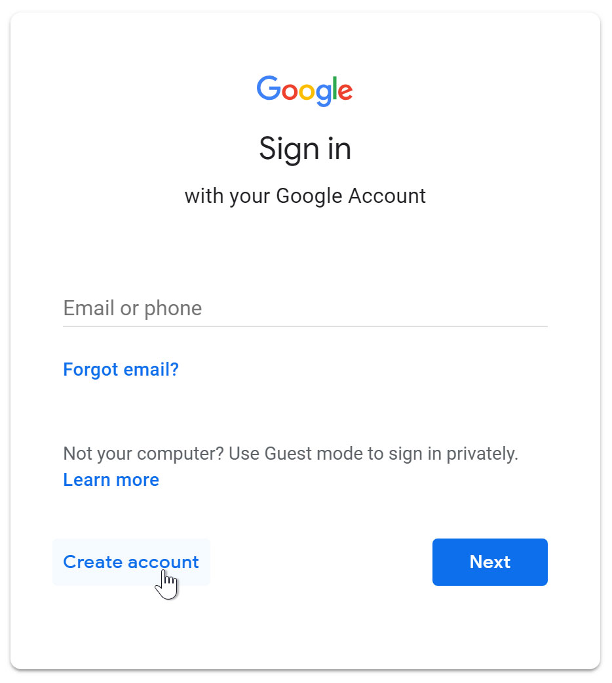

1. The **sign-up** form will appear. Follow the directions by entering the required information.

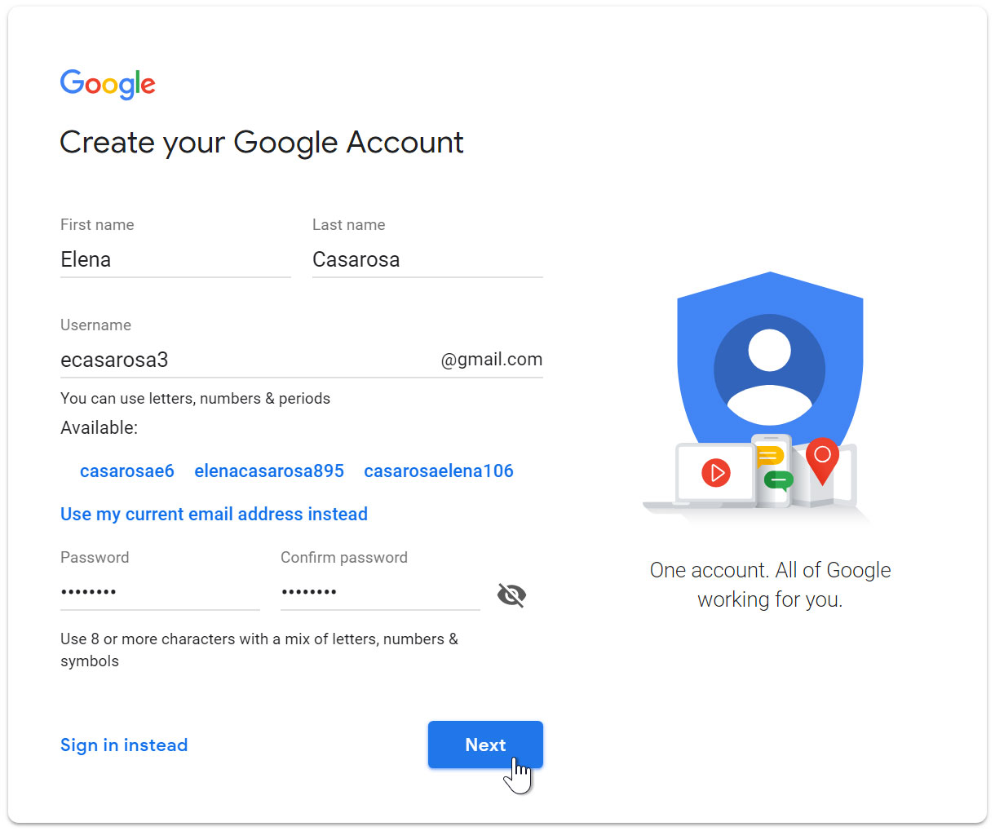

1. Next, enter your **phone number** to verify your account. Google uses a two-step verification process for your security.

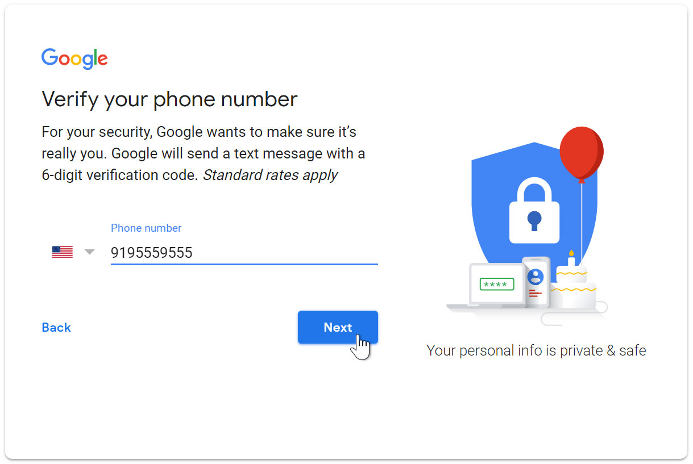

1. You will receive a text message from Google with a **verification code**. **Enter the code** to complete the account verification.

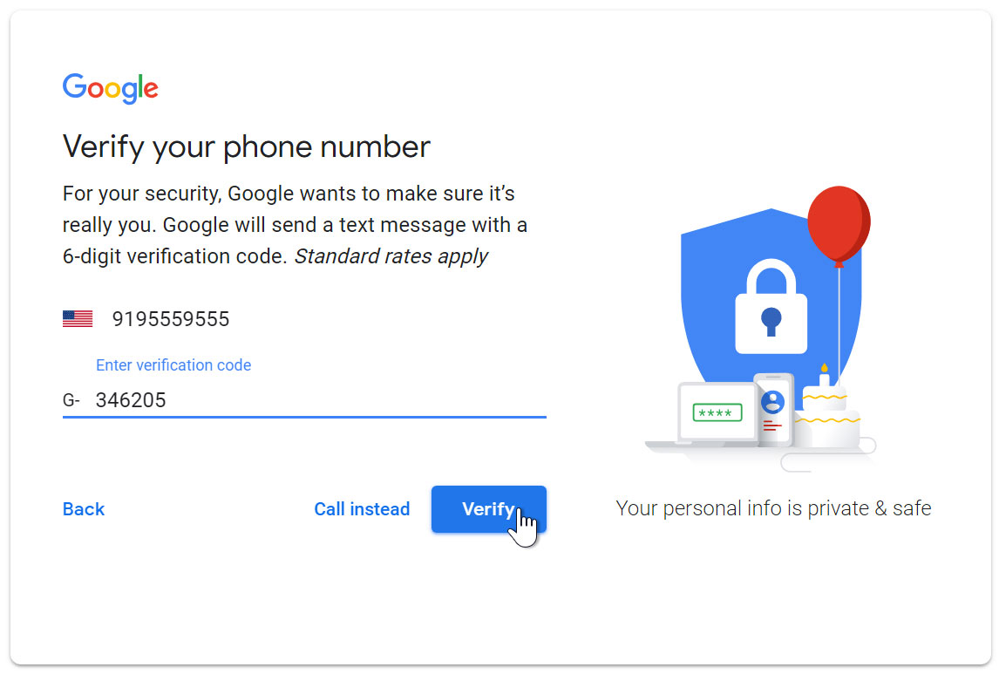

1. Next, you will see a form to enter some of your personal information, like your name and birthday.

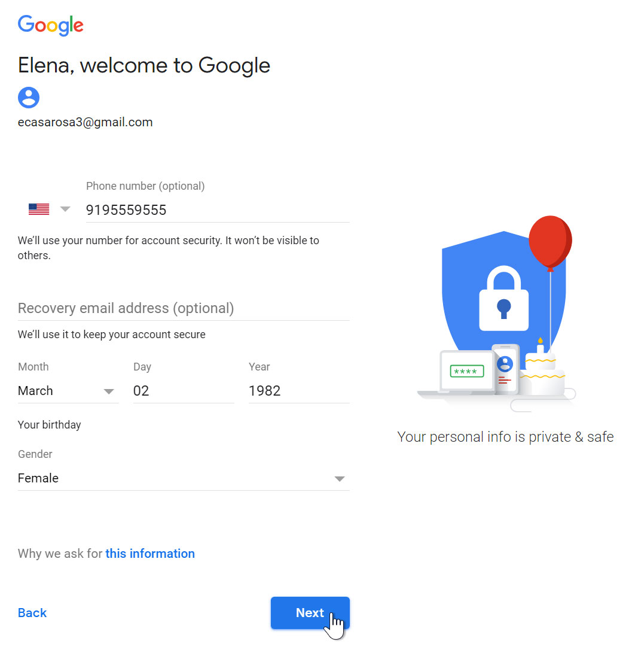

1. Review [Google's Terms of Service](http://www.google.com/intl/en/policies/terms/) and [Privacy Policy](http://www.google.com/intl/en/policies/privacy/), then click **I agree**.

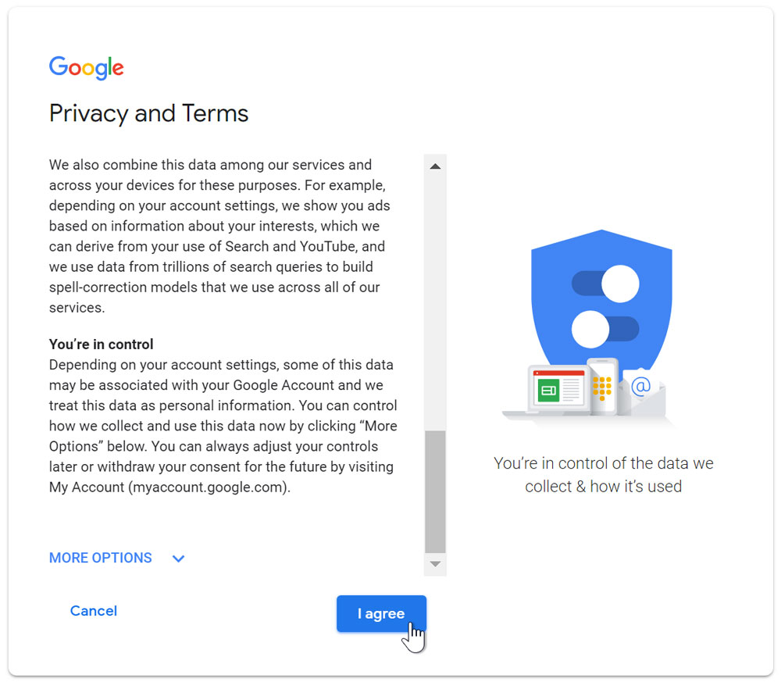

1. Your account will be created.

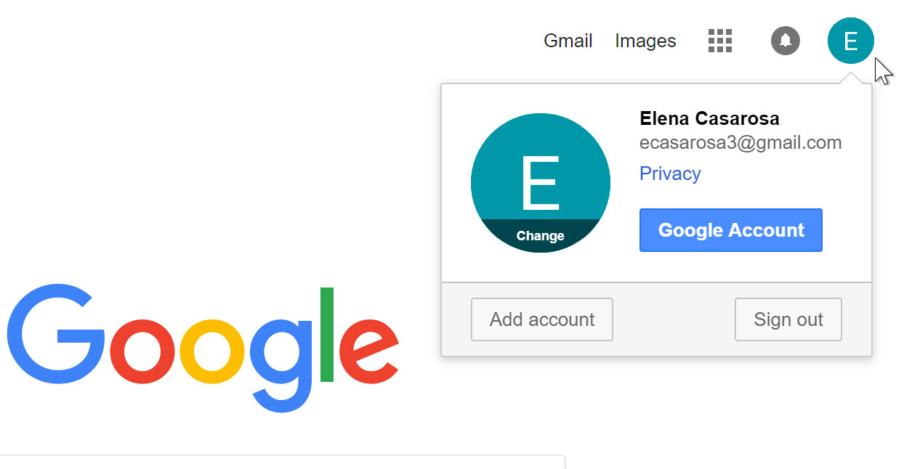

Just like with any online service, it's important to choose a **strong** **password**—in other words, one that is difficult for someone else to guess. For more information, review our lesson on [creating strong passwords](http://www.gcflearnfree.org/internetsafety/creating-strong-passwords/1/).

### **8.3.5 SIGNING IN TO YOUR ACCOUNT**

When you first create your account, you will be automatically signed in. Most of the time, however, you'll need to **sign in** to your account and **sign out** when you're done with it. Signing out is especially important if you're using a shared computer (for example, at a **library** or **office**) because it prevents others from viewing your emails.

#### **To sign in:**

1. Go to [www.gmail.com](http://www.gmail.com).
2. Type your **user name** (your email address) and **password**, then click **Next**.

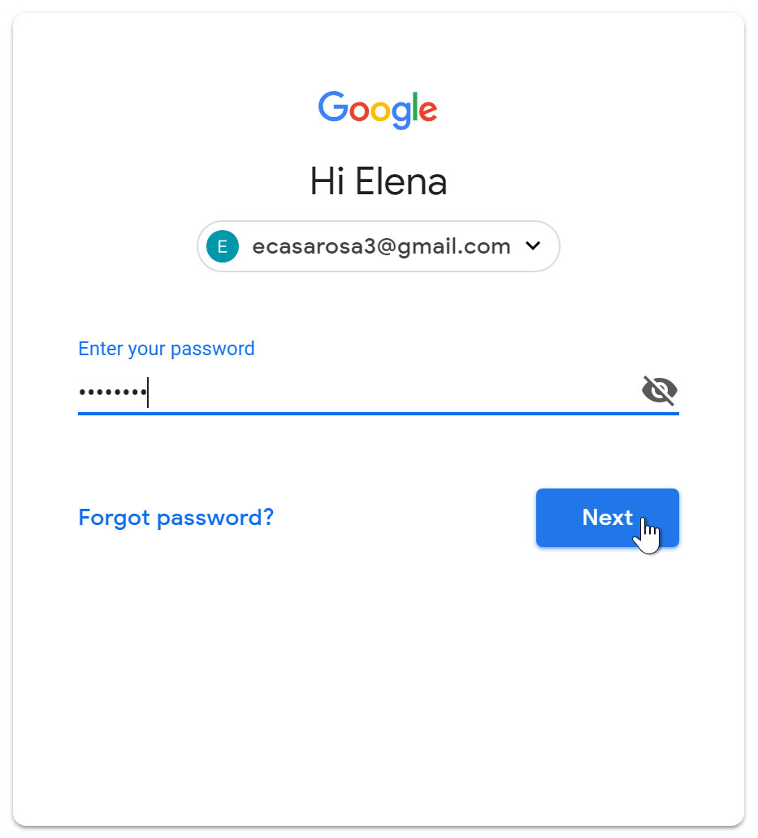

#### **To sign out:**

In the top-right corner of the page, locate the circle that has your first initial (if you've already selected an avatar image, it will show the image instead). To sign out, click the circle and select **Sign out**.

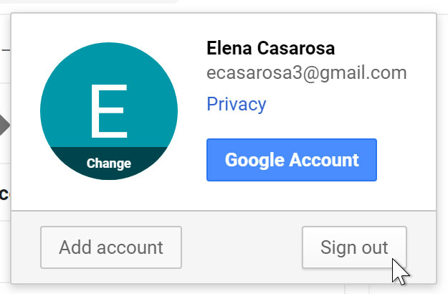

**8.4 ISP**

An Internet Service Provider (ISP) is the industry term for the company that is able to provide you with access to the Internet, typically from a computer. If you hear someone talking about the Internet and they mention their "provider," they're usually talking about their ISP.

Your ISP makes the Internet a possibility. In other words, you can have shiny computer with a built-in modem and could have a router for networking, but without a subscription with an ISP, you won't have a connection to the Internet.

An ISP is your gateway to the Internet and everything else you can do online. The second your connection is activated and set up, you'll be able to send emails, go shopping, do research and more. The ISP is the link or conduit between your computer and all the other "servers" on the Internet. You may feel like you're talking to your mom directly through email, but in reality it's more "indirectly." Your email goes from your computer, to the ISP computers/servers, where it's sent along to its destination through other servers on the network.

Early ISPs provided Internet access through [dial-up](https://techterms.com/definition/dialup) modems. This type of connection took place over regular phone lines and was limited to 56 [Kbps](https://techterms.com/definition/kbps). In the late 1990s, ISPs began offering faster [broadband](https://techterms.com/definition/broadband) Internet access via [DSL](https://techterms.com/definition/dsl) and [cable modems](https://techterms.com/definition/cable_modem).

Some ISPs now offer high-speed fiber connections, which provide Internet access through [fiber optic cables](https://techterms.com/definition/fiber_optic_cable).

To connect to an ISP, you need a modem and an active account. When you connect a modem to the telephone or cable outlet in your house, it communicates with your ISP. The ISP verifies your account and assigns your modem an [IP address](https://techterms.com/definition/ip_address). Once you have an IP address, you are connected to the Internet. You can use a [router](https://techterms.com/definition/router) (which may a separate device or built into the modem) to connect multiple devices to the Internet. Since each device is routed through the same modem, they will all share the same public IP address assigned by the ISP.

ISPs act as hubs on the Internet since they are often connected directly to the Internet [backbone](https://techterms.com/definition/backbone). Because of the large amount of traffic ISPs handle, they require high [bandwidth](https://techterms.com/definition/bandwidth) connections to the Internet. In order to offer faster speeds to customers, ISPs must add more bandwidth to their backbone connection in order to prevent bottlenecks. This can be done by upgrading existing lines or adding new ones.

**8.4.1 FUNCTIONS OF ISP**

* They provide a link to a company or individual which enables them to access World Wide Web
* Connect customers to the nearest Internet gateway.
* Provides a modem for dial-up.
* Connecting an information service to a user of the World Wide Web (www).
* Allows a user to use the services of electronic mail (e-mail).
* Allows a user voice conversations via the internet.
* Gave place to the homepage.
* ISP do protection from the spread of the virus by applying antivirus systems for his customers.

**8.5 CLOUD COMPUTING**

Cloud computing is the delivery of on-demand computing services -- from applications to storage and processing power -- typically over the internet and on a pay-as-you-go basis.

When it comes to providing services, the big players in the corporate computing sphere include:

* Google Cloud
* [Amazon Web Services](https://www.investopedia.com/articles/etfs-mutual-funds/080516/4-etfs-fang-stocks-fdnpnqiqqqskyy.asp) (AWS)
* Microsoft Azure
* IBM Cloud
* Alibaba Cloud

## 8.5.1 BENEFITS OF CLOUD COMPUTING

Cloud computing is a big shift from the traditional way businesses think about IT resources. Here are seven common reasons organizations are turning to cloud computing services:

### **Cost**

Cloud computing eliminates the capital expense of buying hardware and software and setting up and running on-site datacenters—the racks of servers, the round-the-clock electricity for power and cooling, and the IT experts for managing the infrastructure. It adds up fast.

### **Speed**

Most cloud computing services are provided self service and on demand, so even vast amounts of computing resources can be provisioned in minutes, typically with just a few mouse clicks, giving businesses a lot of flexibility and taking the pressure off capacity planning.

### **Global scale**

The benefits of cloud computing services include the ability to scale elastically. In cloud speak, that means delivering the right amount of IT resources—for example, more or less computing power, storage, bandwidth—right when they’re needed, and from the right geographic location.

### **Productivity**

On-site datacenters typically require a lot of “racking and stacking”—hardware setup, software patching, and other time-consuming IT management chores. Cloud computing removes the need for many of these tasks, so IT teams can spend time on achieving more important business goals.

### **Performance**

The biggest cloud computing services run on a worldwide network of secure datacenters, which are regularly upgraded to the latest generation of fast and efficient computing hardware. This offers several benefits over a single corporate datacenter, including reduced network latency for applications and greater economies of scale.

### **Reliability**

Cloud computing makes data backup, disaster recovery, and business continuity easier and less expensive because data can be mirrored at multiple redundant sites on the cloud provider’s network.

### **Security**

Many cloud providers offer a broad set of policies, technologies, and controls that strengthen your security posture overall, helping protect your data, apps, and infrastructure from potential threats.

## 8.5.2 TYPES OF CLOUD COMPUTING

Not all clouds are the same and not one type of cloud computing is right for everyone. Several different models, types, and services have evolved to help offer the right solution for your needs.

First, you need to determine the type of cloud deployment, or cloud computing architecture, that your cloud services will be implemented on. There are three different ways to deploy cloud services: on a public cloud, private cloud, or hybrid cloud.

### **Public cloud**

Public clouds are owned and operated by a third-party [cloud service providers](https://azure.microsoft.com/en-us/overview/choosing-a-cloud-service-provider/), which deliver their computing resources, like servers and storage, over the Internet. Microsoft Azure is an example of a public cloud. With a public cloud, all hardware, software, and other supporting infrastructure is owned and managed by the cloud provider. You access these services and manage your account using a web browser.

### **Private cloud**

A private cloud refers to cloud computing resources used exclusively by a single business or organization. A private cloud can be physically located on the company’s on-site datacenter. Some companies also pay third-party service providers to host their private cloud. A private cloud is one in which the services and infrastructure are maintained on a private network.

### **Hybrid cloud**

Hybrid clouds combine public and private clouds, bound together by technology that allows data and applications to be shared between them. By allowing data and applications to move between private and public clouds, a hybrid cloud gives your business greater flexibility, more deployment options, and helps optimize your existing infrastructure, security, and compliance.

## 8.5.3 USES OF CLOUD COMPUTING

You’re probably using cloud computing right now, even if you don’t realize it. If you use an online service to send email, edit documents, watch movies or TV, listen to music, play games, or store pictures and other files, it’s likely that cloud computing is making it all possible behind the scenes. The first cloud computing services are barely a decade old, but already a variety of organizations—from tiny startups to global corporations, government agencies to non-profits—are embracing the technology for all sorts of reasons.

Here are a few examples of what’s possible today with cloud services from a cloud provider:

### Create cloud-native applications

Quickly build, deploy, and scale applications—web, mobile, and API. Take advantage of [cloud-native](https://azure.microsoft.com/en-us/overview/cloudnative/) technologies and approaches, such as containers, [Kubernetes](https://azure.microsoft.com/en-us/topic/what-is-kubernetes/), microservices architecture, API-driven communication, and DevOps.

### **Test and build applications**

Reduce application development cost and time by using cloud infrastructures that can easily be scaled up or down.

### **Store, back up, and recover data**

Protect your data more cost-efficiently—and at massive scale—by transferring your data over the Internet to an offsite cloud storage system that’s accessible from any location and any device.

### **Analyze data**

Unify your data across teams, divisions, and locations in the cloud. Then use cloud services, such as machine learning and artificial intelligence, to uncover insights for more informed decisions.

### **Stream audio and video**

Connect with your audience anywhere, anytime, on any device with high-definition video and audio with global distribution.

### **Embed intelligence**

Use intelligent models to help engage customers and provide valuable insights from the data captured.

### **Deliver software on demand**

Also known as software as a service (SaaS), on-demand software lets you offer the latest software versions and updates around to customers—anytime they need, anywhere they are.

**8.6 IOT**

The Internet of Things, or IoT, refers to the billions of physical devices around the world that are now connected to the internet, all collecting and sharing data. Thanks to the arrival of super-cheap computer chips and the ubiquity of wireless networks, it's possible to turn anything, from something as small as [a pill](https://www.zdnet.com/article/how-sensors-enabled-eli-lilly-to-improve-the-patient-experience/) to something as big as [an aeroplane](https://www.zdnet.com/article/ten-examples-of-iot-and-big-data-working-well-together/), into a part of the IoT. Connecting up all these different objects and adding sensors to them adds a level of digital intelligence to devices that would be otherwise dumb, enabling them to communicate real-time data without involving a human being. The Internet of Things is making the fabric of the world around us more smarter and more responsive, merging the digital and physical universes.

The Internet of Things (IoT) describes the network of physical objects—“things”—that are embedded with sensors, software, and other technologies for the purpose of connecting and exchanging data with other devices and systems over the internet. These devices range from ordinary household objects to sophisticated industrial tools. With more than 7 billion connected IoT devices today, experts are expecting this number to grow to 10 billion by 2020 and 22 billion by 2025.

**8.6.1 WHAT IS AN EXAMPLE OF AN INTERNET OF THINGS DEVICE?**

Any physical object can be transformed into an IoT device if it can be connected to the internet to be controlled or communicate information.

[**A lightbulb**](https://www.zdnet.com/article/building-my-own-internet-of-things-ambient-experience-one-step-at-a-time/) that can be switched on using a smartphone app is an IoT device, as is a motion sensor or a [**smart thermostat**](https://www.zdnet.com/article/johnson-controls-cortana-powered-thermostat-is-up-for-preorder-in-march/) in your office or a connected streetlight. An IoT device could be as fluffy as [a **child's toy**](https://www.zdnet.com/article/fbi-to-parents-beware-your-kids-smart-toy-could-be-a-security-risk/) or as serious as [a driverless truck](https://www.zdnet.com/article/driverless-trucks-are-coming-but-for-now-adoption-is-in-the-slow-lane/). Some larger objects may themselves be filled with many smaller IoT components, such as a jet engine that's now filled with thousands of sensors collecting and transmitting data back to make sure it is operating efficiently.

At an even bigger scale, [**smart cities projects** are filling entire regions with sensors](https://www.zdnet.com/article/las-vegas-announces-smart-city-plans-with-cisco/) to help us understand and control the environment.

A [**smartwatch**](https://www.zdnet.com/article/could-your-apple-watch-save-your-life-how-smartwatch-sensors-are-helping-tackle-a-dangerous-heart/) or a [fitness band](https://www.zdnet.com/product/fitbit-ionic/) or other wearable device might be counted as an IoT device.

**8.6.2 APPLICATIONS OF IOT**

Organizations best suited for IoT are those that would benefit from using sensor devices in their business processes.

#### **Manufacturing**

Manufacturers can gain a competitive advantage by using production-line monitoring to enable proactive maintenance on equipment when sensors detect an impending failure. Sensors can actually measure when production output is compromised. With the help of sensor alerts, manufacturers can quickly check equipment for accuracy or remove it from production until it is repaired. This allows companies to reduce operating costs, get better uptime, and improve asset performance management.

#### **Automotive**

The automotive industry stands to realize significant advantages from the use of IoT applications. In addition to the benefits of applying IoT to production lines, sensors can detect impending equipment failure in vehicles already on the road and can alert the driver with details and recommendations. Thanks to aggregated information gathered by IoT-based applications, automotive manufacturers and suppliers can learn more about how to keep cars running and car owners informed.

#### **Transportation and Logistics**

Transportation and logistical systems benefit from a variety of IoT applications. Fleets of cars, trucks, ships, and trains that carry inventory can be rerouted based on weather conditions, vehicle availability, or driver availability, thanks to IoT sensor data. The inventory itself could also be equipped with sensors for track-and-trace and temperature-control monitoring. The food and beverage, flower, and pharmaceutical industries often carry temperature-sensitive inventory that would benefit greatly from IoT monitoring applications that send alerts when temperatures rise or fall to a level that threatens the product.

#### **Retail**

IoT applications allow retail companies to manage inventory, improve customer experience, optimize supply chain, and reduce operational costs. For example, smart shelves fitted with weight sensors can collect RFID-based information and send the data to the IoT platform to automatically monitor inventory and trigger alerts if items are running low. Beacons can push targeted offers and promotions to customers to provide an engaging experience.

#### **Public Sector**

The benefits of IoT in the public sector and other service-related environments are similarly wide-ranging. For example, government-owned utilities can use IoT-based applications to notify their users of mass outages and even of smaller interruptions of water, power, or sewer services. IoT applications can collect data concerning the scope of an outage and deploy resources to help utilities recover from outages with greater speed.

#### **Healthcare**

IoT asset monitoring provides multiple benefits to the healthcare industry. Doctors, nurses, and orderlies often need to know the exact location of patient-assistance assets such as wheelchairs. When a hospital’s wheelchairs are equipped with IoT sensors, they can be tracked from the IoT asset-monitoring application so that anyone looking for one can quickly find the nearest available wheelchair. Many hospital assets can be tracked this way to ensure proper usage as well as financial accounting for the physical assets in each department.

#### **General Safety Across All Industries**

In addition to tracking physical assets, IoT can be used to improve worker safety. Employees in hazardous environments such as mines, oil and gas fields, and chemical and power plants, for example, need to know about the occurrence of a hazardous event that might affect them. When they are connected to IoT sensor–based applications, they can be notified of accidents or rescued from them as swiftly as possible. IoT applications are also used for wearables that can monitor human health and environmental conditions. Not only do these types of applications help people better understand their own health, they also permit physicians to monitor patients remotely.